# Towards Breathable Cities: Shaping Low Emission Zones in Jakarta

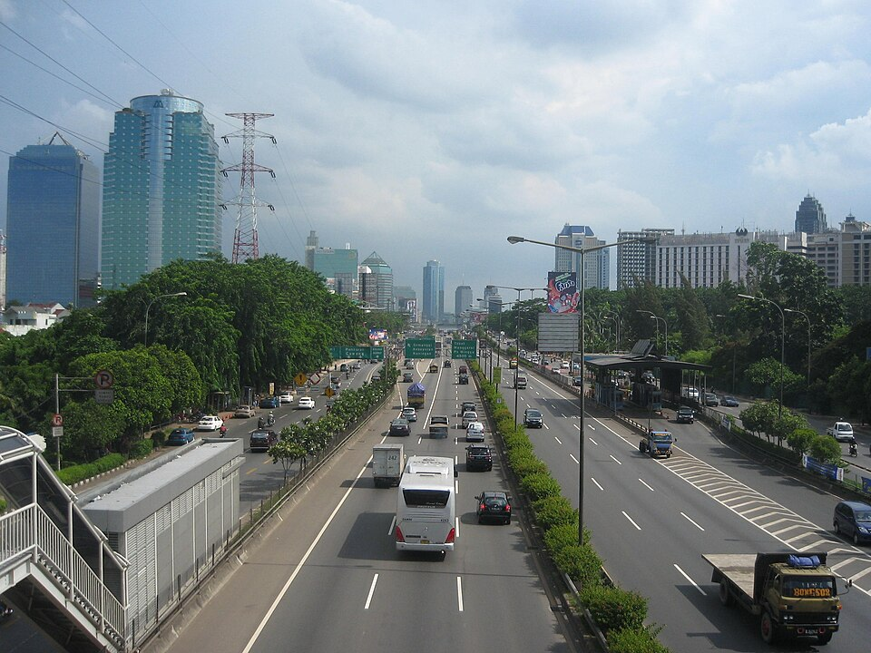 CC [File:Distributor Herbalife Jakarta 081219552488 - panoramio.jpg - Wikimedia Commons](https://commons.wikimedia.org/wiki/File:Distributor_Herbalife_Jakarta_081219552488_-_panoramio.jpg)

Jakarta took a step closer in its journey toward a more sustainable, breathable future in April, as Sergi Sauri and Tomas Henriquez from CIMNE’s Innovation Unit in Transport ([CENIT](https://www.cimne.com/space/2192)) led a **validation workshop focused on shaping the city's future Integrated Low Emissions Zones** (**Kawasan Rendah Emisi Terpadu – KRE-T**). Hosted in the local language, Bahasa Indonesia, the workshop was a milestone in the development of Jakarta’s KRE-T pilot project, part of the Breathe Cities Programme supported by C40 Cities.

**Understanding Jakarta’s Urban Complexities**

The purpose of this workshop was to validate CIMNE experts' key findings from their preliminary study, with participation from **Jakarta government representatives** from multiple departments, along with **local NGOs** and **local stakeholders**. Their insights were invaluable in validating the project’s key findings and tailoring the approach to the real-world complexities of Jakarta’s urban fabric.

«The KRE-T project is unique in how it chooses to address not just the transportation sector, as has become customary, but also other major polluting sectors in tandem, while aiming to **increase urban resilience and livability through improved equity and increased green and blue spaces within the urban fabric**», Mr Henriquez said.

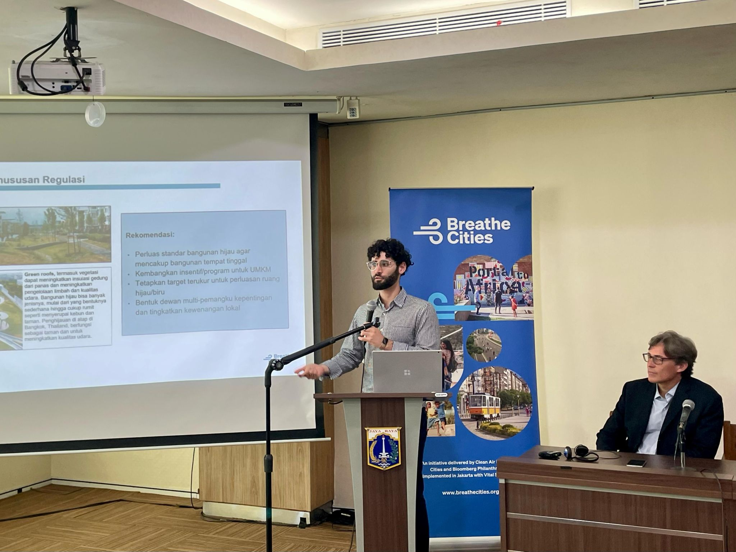 Tomas Henriquez during his intervention at the Jakarta workshop on Low Emission Zones.

**Objectives for the Low Emission Zones**

This project aims to identify, test, and scale integrated low emission zones across the city. It focuses on three major policy objectives:

* **Improving air quality and congestion** in designated areas
* **Reducing emissions**, particularly from the transportation, building, energy, and waste sectors,
* **Equitably improving quality of life** and increasing access to green and blue areas.

**From Academic Research to Local Needs**

This workshop builds on several months of groundwork, including an in-depth feasibility assessment and regulatory analysis, as well as the creation of a criteria framework to identify **high-potential areas for pilot implementation**. The framework takes into account critical elements such as **mobility**, **land use**, **urban equity**, **infrastructure**, and **the built environment**, evaluated through a multi-dimensional lens that **balances environmental goals with social equity and urban livability**.

«The validation workshop in Jakarta enabled our team to marry **the technical analysis and academic research** of the proposed KRE-T with the **real needs and challenges of the citizenry and leadership of Jakarta**», explained Tomas Henriquez. «This workshop and our direct collaboration with teams on the ground will inevitably increase the project’s potential for **long-term success** and we could not feel prouder to play a part in this next chapter of Jakarta’s future».

The event was marked by active participation from all stakeholders, reflecting a **clear, shared commitment to advancing the project and supporting Jakarta’s transition toward more sustainable urban environments**. Using **gamification,** the CIMNE experts conducted an engaging series of activities that emphasized not only **validation** but also **co-creation** with those most familiar with the opportunities and challenges of Jakarta. The workshop also functioned as a space for meaningful collaboration, bringing together **international expertise** and **local knowledge** to shape practical, context-sensitive solutions.

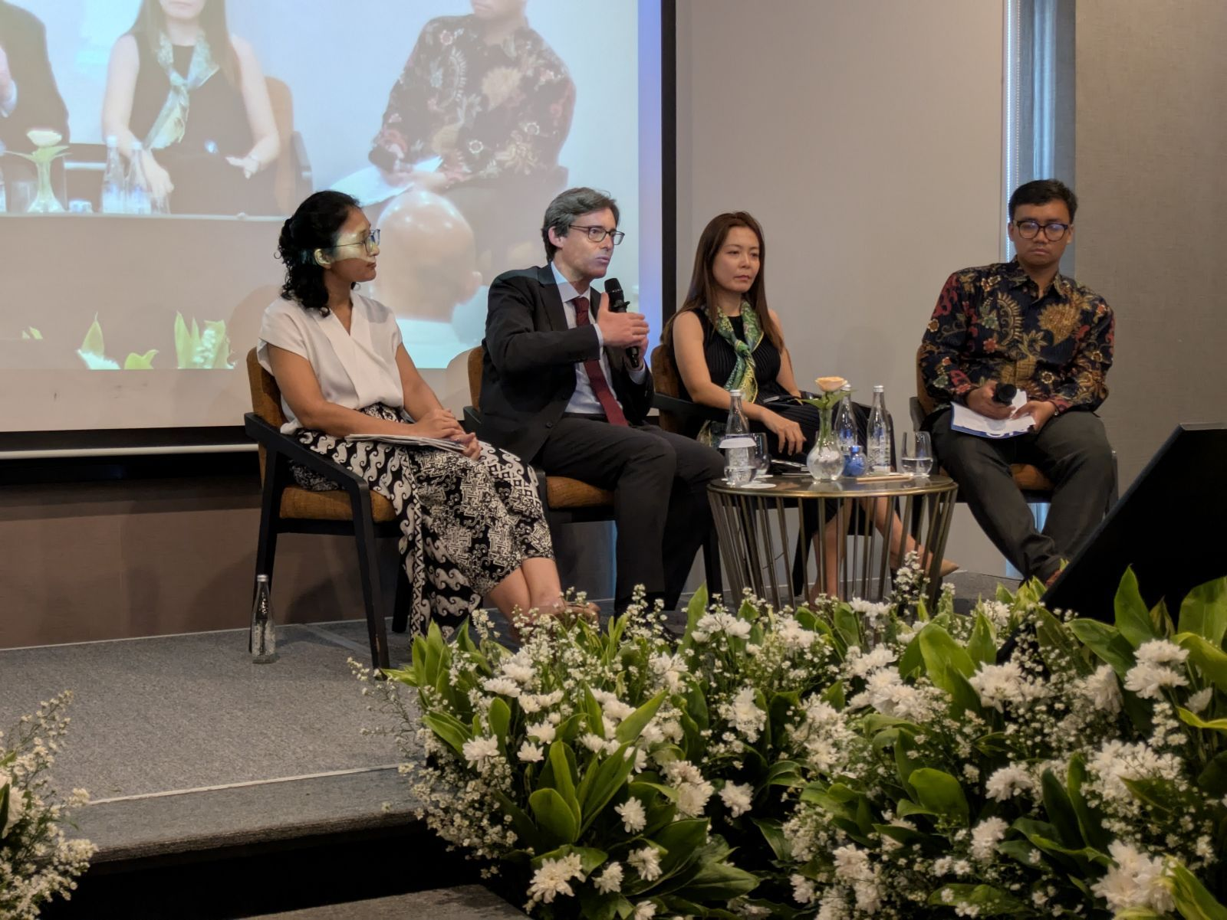 Sergi Saurí and Jakarta government representatives at the workshop on Low Emission Zones.

**Next step: a pilot implementation plan**

With the validation workshop complete, the project team is moving into the final phase: **refining guidelines and shaping a pilot implementation plan for the first KRE-T zones in Jakarta**.

Tomas Henriquez shared his hope that Jakarta’s efforts will serve as a model: «We hope this project will serve as an **inspiration** for other cities struggling with similar livability and air quality issues to **implement their own integrated low emission zones**».

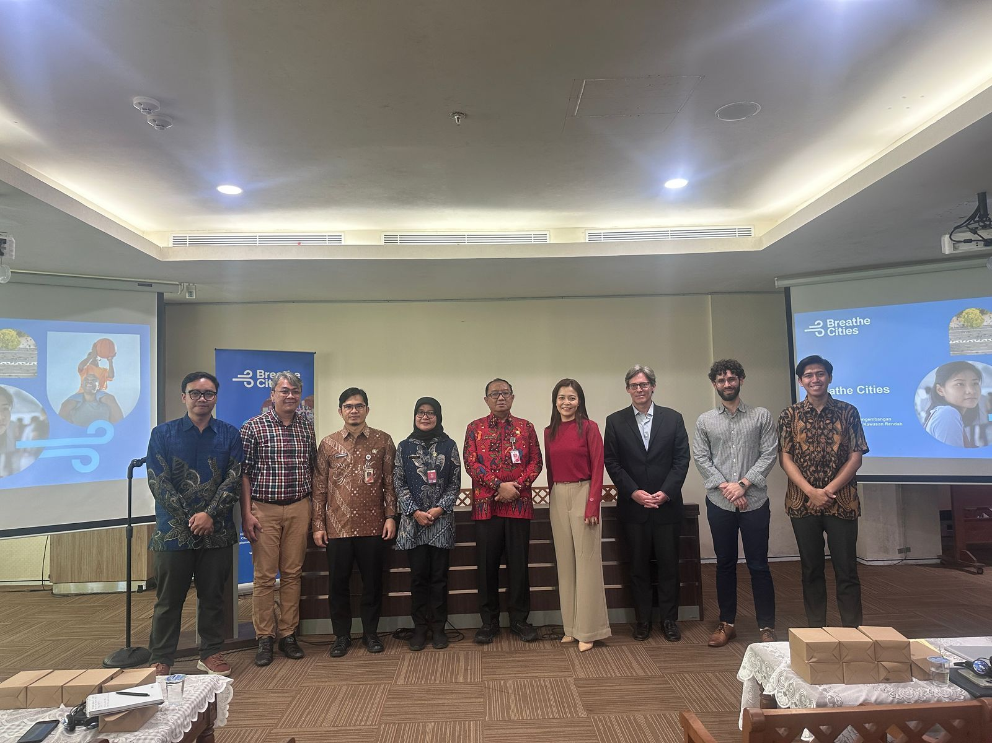 CIMNE experts and Jakarta government representatives at the workshop on Low Emission Zones.

Post LinkedIn

👣 **Final steps in the KRE-T Project**: Jakarta moves closer to becoming a more breathable city through a workshop focused on its future Integrated Low Emission Zones. Here’s what we did 👇🏼

Researchers from CIMNE’s Innovation Unit in Transport (CENIT) led a validation workshop in Jakarta, engaging with local government representatives, NGOs, and community stakeholders to refine the roadmap for the city’s Integrated **Low Emission Zones (Kawasan Rendah Emisi Terpadu – KRE-T)** — a key initiative within the Breathe Cities Programme supported by @C40 Cities.

The workshop marked a milestone in Jakarta’s climate journey. Dr @Sergi Sauri and @Tomas Henriquez from CIMNE combined their technical expertise with local knowledge. Through gamification techniques and participatory sessions, CIMNE experts co-created solutions with those most familiar with the opportunities and challenges of Jakarta.

🧩The KRE-T project merges **rigorous research with the real needs and challenges of Jakarta’s urban landscape.** «This will inevitably increase the project’s potential for long-term success and we could not feel prouder to play a part in this next chapter of Jakarta’s future», Tomas Henriquez said.

✨ **Why this project matters**

• Tackles pollution across transport, buildings, energy, and waste  
• Supports Jakarta’s transition toward more sustainable urban environments  
• Improves air quality, reduces emissions, and enhances quality of life  
• Bridges global expertise and local realities  
• Inspires other cities to implement their own integrated low emission zones

📃 Learn more about this initiative:

#CIMNE #CENIT #BreatheCities #Jakarta #LowEmissionZones #Mobility #Sustainability #AirQuality #Research #Innovation