COMMUNICATION SKILLS

Master of Science in Computational Mechanics

Master Metodos Numericos en Ingenieriıa

**GREEN BUILDING**

TROND JORGEN OPHEIM, FLORIAN VAN VUEGT AND MERLE SCHMITT

Laboratory of Computational Methods and Numerical Analysis (LaCaN)

Universidad Polit́ecnica de Cataluña

Campus Norte UPC, 08034 Barcelona, Spain

Edificio C1, Campus Norte UPC

Gran Capitán s/n, 08034 Barcelona, Spain

**1 INTRODUCTION**

There are a lot of existential problem on our earth. The three big ones regarding our future are: Fossil oil deposits are shrinking, our earth is getting warmer and the sea levels are rising. The solution for this seems to be easy. We have to change something. But what can we change? Which ideas exist, that about 7 billions people can live on this earth without destroying it? Some things are really simple. For example, everybody can be a little bit more sustainable.

**2 SUSTAINABILITY**

The field of sustainability examines the efficiency of processes. Basically every aspect of live could be analyzed under this point of view. Two of these areas are the housing market and construction sites, which will be discussed more detailed in further sections.

It means, you deal responsible with the resources of the earth. Goal of it is to conserve a livable environment for the next generations. Sustainability overlaps three different areas: Economy, society and environment. Creating sustainability works only through the interaction between these three pillars. The economic aspect makes a business profitable. Socio-cultural wealth for every person, who make up the business as well as their stakeholders. Finally the environment, in which the population and also the business take place. The coincident and equivalent implementation of all three aspects is the solution for sustainability.

**3 WHAT IS GREEN BUILDING**

Green Building is a construction idea, which was developed with the main idea of sustainability. This is associated with a high resource efficiency in the segment of energy, water and materials to reduce negative impacts on the human healthiness and also on our climate and natural environment.

The goal is to improve our quality of live and remain a livable and intact environment to the future generations. The idea is strong related with the three columns of sustainability: environmental benefits, economic benefits and socio-cultural benefits.

Therefore, these components must be always applied about all phases of the life cycle of a building.

**4 GOALS**

But why is it so important, that this main idea will be realized in the future? The greatest problems are, first, too much energy consumption and therefore too much CO2 emission. The consume by buildings is 40 percent of the total energy usage. So, if you minimize the high emission, the first step is to decrease the pollution of environment. Another problem is the behavior of our society associated with the high production of waste. In that context, the construction field “materials” are very important for the implementation of the sustainable concept. Due to the new sustainable developments in the range of construction materials, you can minimize waste. One idea for example is the biodegradability of materials. Further you can reutilize construction materials. These are two ways, to improve the ecological footprint and to minimize the pollution. In the long term this will increase the health and wealth of the next generations. Additionally the environment will benefit and prosper.

**5 HOW IT CAN LOOK LIKE**

The basic idea of Green building is to maximize the efficiency and to increase the consumption of renewable resources. For these purposes the usage of new technologies are unavoidable. This could be e.g. the installation of solar panels.

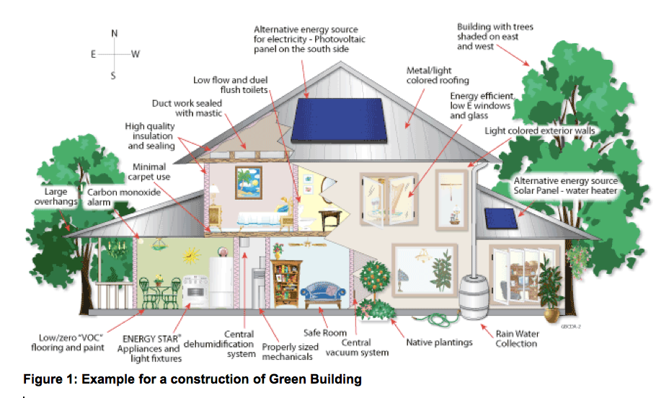

**5.1 Key objectives**

As already mentioned in section 3, there are three different main segments and also key objectives, which should be considered in a construction of a Green Building.

First the energy efficiency, which has the goal to reduce the energy consumption over the whole life cycle. There are a lot of factors, like cladding, plating, heating, justification of a building, etc., which should be taken into account. In this case, a good preparation and planning has a big importance. For example locally generated renewable energy with solar panels can reduce the environmental impact significantly.

Second, the water efficiency, which means reducing the water consumption and protecting the water quality. One option can be the collection of rainwater and the usage for toilets or the garden. Another option is just to minimize the water consumption by water conserving fixtures.

The third segment is the material efficiency. It is the utilisation of typically green building materials. It can be plant materials like wood, bamboo and straw, dimension stone, recycled stone, recycled metal, which is rapidly renewable as well as other products that are non-toxic, reusable, renewable, and/or recyclable. The reutilization of building materials is part of the idea of the Green Building construction system. All other criterias are derived from the certifications and rating systems, with which the building should correspond in the end.

**5.2 Green Building examples**

There are a lot of examples of different Green Buildings all over the world with varying rating certificates. Some of these have two certificates, for example the German DGNB and also the U.S. LEED certificate, which is the best case of Green Building. For example the Arena Boulevard Building in Berlin, which has the DGNB gold and also the LEED platinum certificate. Another famous building is the Hearst Tower in New York, certified by LEED.

**6 REGULATION**

Buildings have an impact on the environment. During the construction, lifetime and under demolition the building will use water, materials and energy. It will produce waste and potentially emissions that can be harmful for the environment. By following different guidelines and rules, the owner of the building will ensure to have a healthy, efficient and cost-saving building, and a certification recognized of sustainability.

In this section we will go through some of them and what they mean for the green building process.

**6.1 Codes and standards**  
Green building codes and standards are guidelines and rules of building design and construction, developed to give buildings higher and better performance and sustainability. The difference between a code and a standard is that a code is mandatory to follow, while the standards are not.  
The requirements stated in these codes and standards are either prescribed or performance based. This means that for specific building parts or whole constructions, the requirement is set for the quality of the part and method used when assembling it, or the final result for the whole construction.

**6.2 Rating systems**  
Rating systems broaden the focus. They look at the whole building as one unit. The building with all its installations and functions is rated out from its impact on the environment. Under the process of rating the building, a independent third-party goes through the building and gives point to the functions and installations regarding several areas like pollution, materials, waste, health. At the end the points are summed up and the building gets a certificate from its performance. There are a lot of rating systems all over the world, over 60 Green Building labels.

The most used rating system is “Leadership in Energy and Environmental Design” (LEED) developed by U.S. Green Building Council, and another common rating system is the “Building Research Establishment Environmental Assessment Method”, also known as the BREEAM, which is the oldest one and contains the most different categories. Another one is the German DGNB, which is unique, because it assesses a building over the entire life cycle. It is also the strictest one in comparison with the others.

For example LEED is a rating system which focus on indoor environment, water efficiency etc. while the DGNB focus on all the pillars of sustainability and the technical factor.

Common for LEED, BREEAM and other rating systems is that they rate the buildings out from its impact on the environment, and certify them with a score. For example LEED gives a rating from “Certified”, “Silver”, “Gold” or “Platinum”, while BREEAM certifies with the scale “Pass”, “Good”, “Very Good”, “Excellent” and “Outstanding”.

**7 CRITICAL VIEW**

But in the critical consideration it needs more time for the implementation. In fact, there are already a few Green Buildings, but society and the construction industry have to increase their engagement to reach a sustainable future. An instrument to reach that goal could be the increase of certificated Green Buildings.

**REFERENCES**

[1] “Green building” on: https://en.wikipedia.org/wiki/Green_building (4.11.2017)

[2] “What is green building” on: http://www.worldgbc.org/what-green-building (5.11.2017)

[3] “Basic Information about Green Building” on: https://archive.epa.gov/greenbuilding/web/html/about.html (5.11.2017)

[4] “What is a Green Building and Benefits of Green Buildings?” on: http://businessfeed.sunpower.com/articles/written-what-is-a-green-building (4.11.2017)

[5] “Green Building Standards and certification systems” on: https://www.wbdg.org/resources/green-building-standards-and-certification-systems (13.12.2017)