NACA0015 + Synthetic Jet TestCase Definition
Case coordinators: Prof. Tang Zhili, NUAA
Prof. Liu Guozheng, ARI
The included test case was conducted by NUAA and ARI.

Computational domain
- upstream: 20*C far away from leading edge,
- downstream: 20*C far away from trailing edge,
- top boundary: 20*C far away from chord line,
- bottom boundary: 20*C far away from chord line.
- C is the chord length, C=500mm
- Spanwise length =200mm
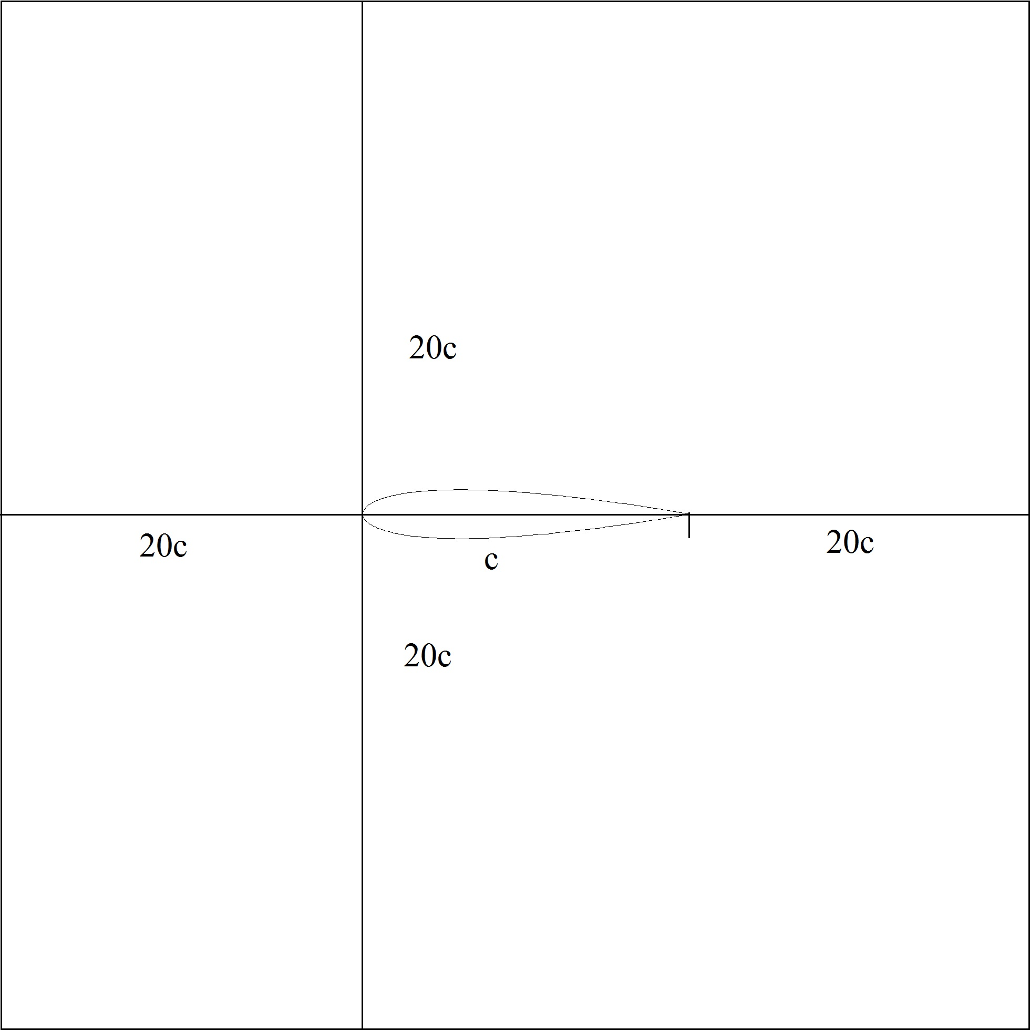

Figure 1. Diagram of computational domain

Boundary condition
- left and right boundary: periodic boundary condition
- upstream, down stream, top and bottom boundary: far field boundary condition, free stream velocity=10,20,30m/s, angle of attack=18deg.
- wall: no-slip boundary condition

Flow analyzer
- 3D URANS with Turbulence Model

Devices geometry of SJ
- Defined by experiment
- Width of slot: 1.5mm

Design variables
- frequency of jet: f,
- amplitude of jet flow: V_Jet,
- direction of jet flow: Theta,
- position of jet flow exit: p.
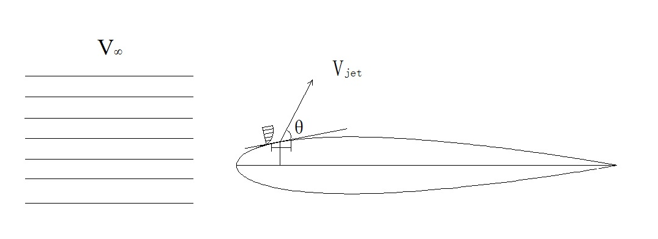

Figure 2. Control device parameters for optimization

Search space
- V_jet=[30m/s,80m/s],
- frequency=[30Hz,60Hz],
- Theta=[30deg,160deg],
- Position of jet: p=[5%C-7%C]

Objective function: J
- Maximize J=averaged lift:

Constraints
- No constraints

Optimizer
- Genetic algorithms with adaptive surrogate model

Data outputs (to be decided)
- Cl with respect to t (time)
- Cd with respect to t (time)
- several periods of zoomed flow fields
- separation point
- separation region
- …….

Outputs data formats
- Tecplot data formats (to be decided)

Remark: 2D NACA0015 airfoil + SJ is also available from the above definition with the same parameters of the same device design parameter of fig. 2.

