**DATA OF BFS PROVIDED BY NUAA WP2 TEAM**

**Geometry of BFS model**

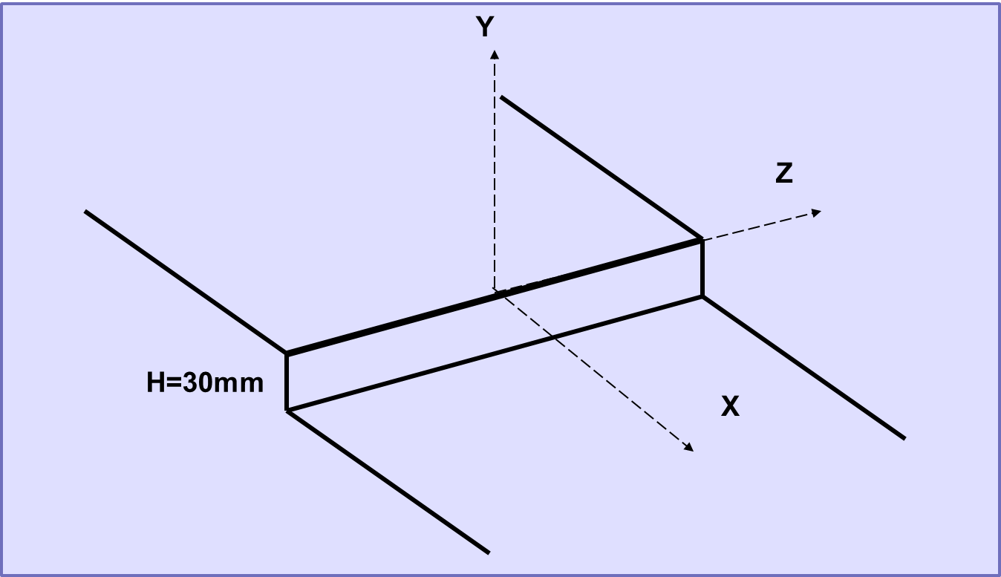

**EXPERIMENTAL CURVES**

**BFS_ BL_ EXP_MCP_NUAA**

**Pressure coefficient**

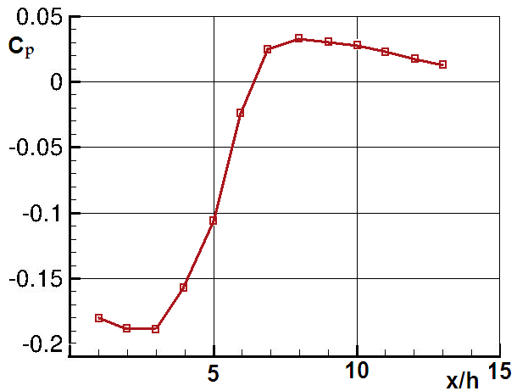

**BFS_ BL_ EXP_MSF_NUAA**

**Skin friction**

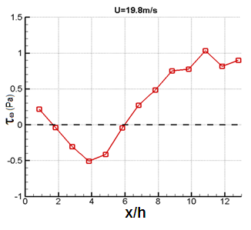

**BFS_ BL_ EXP_MRA_NUAA**

**X/h=6 (free stream velocity U=19.8)**

**BFS_ BL_ EXP_TAS_NUAA**

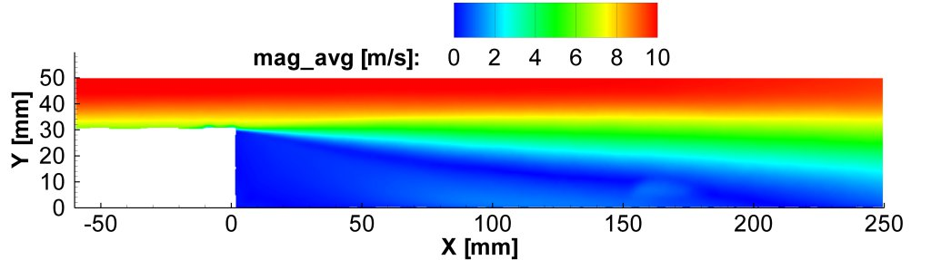

**BFS_ BL_ EXP_TSS_NUAA**

**Profile of mean velocity, turbulence intensity, and Reynolds stress**

**X=1h**

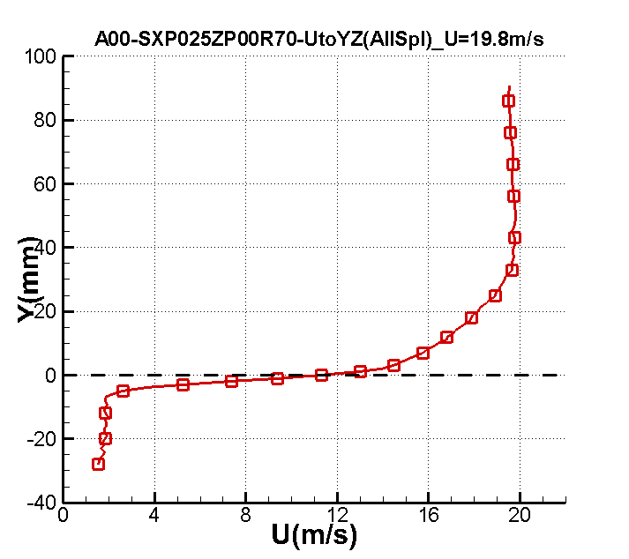

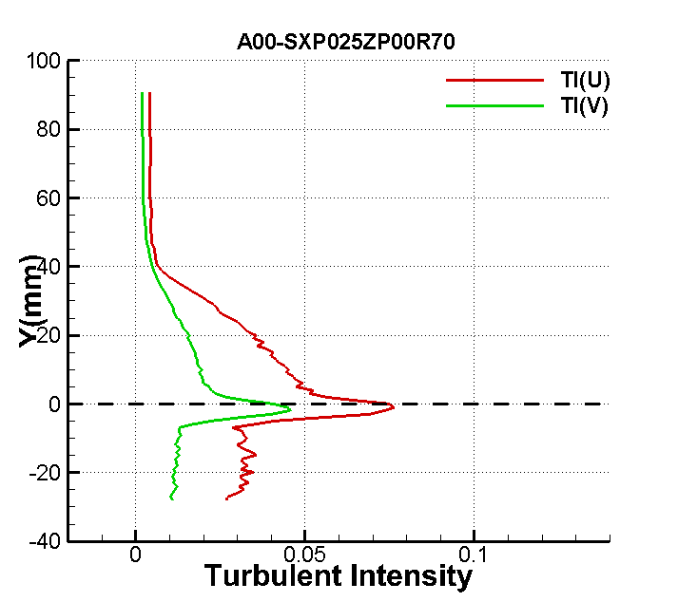

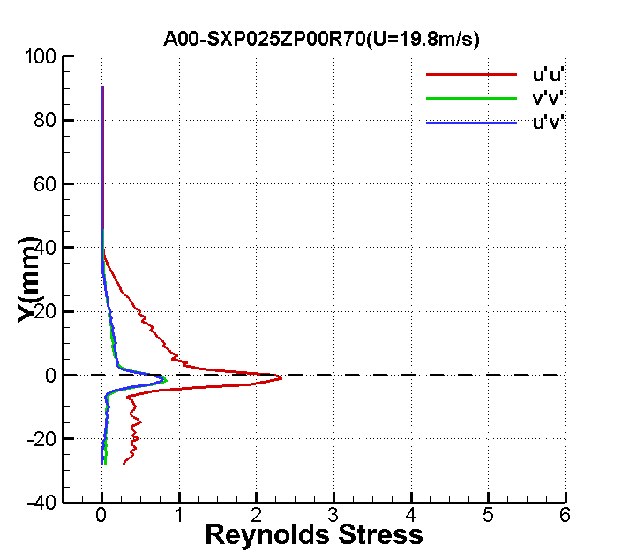

**X=2h**

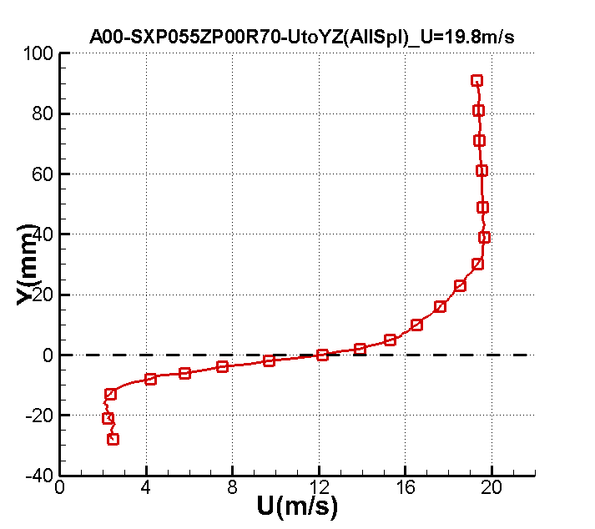

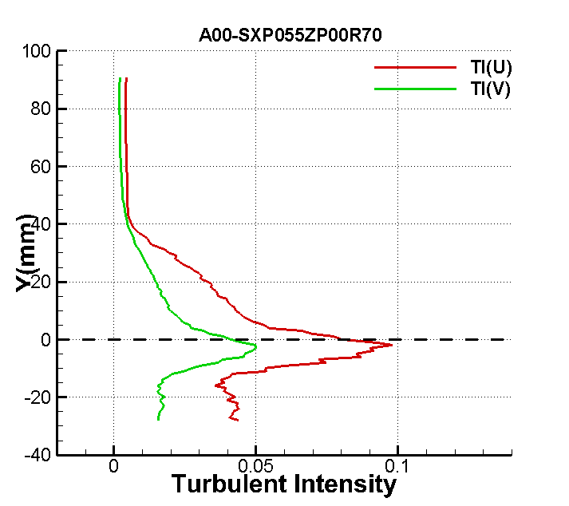

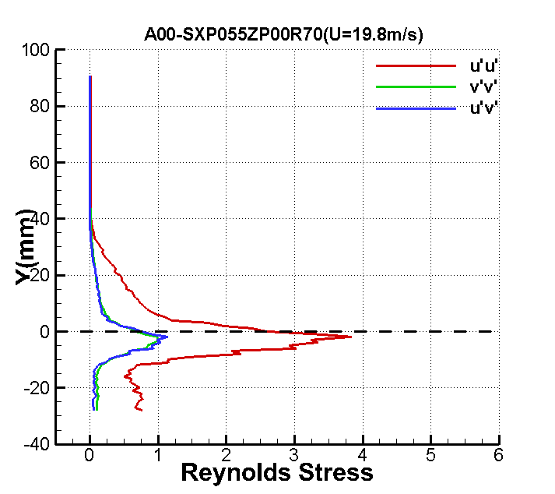

**X=3h**

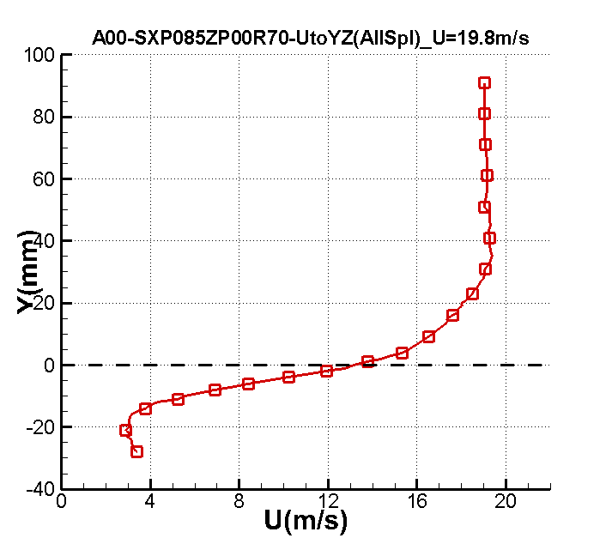

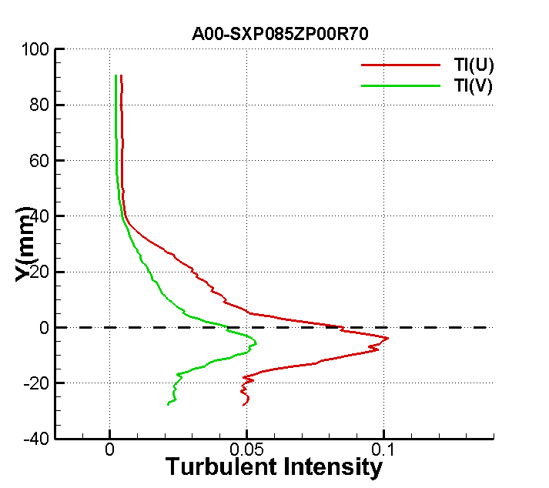

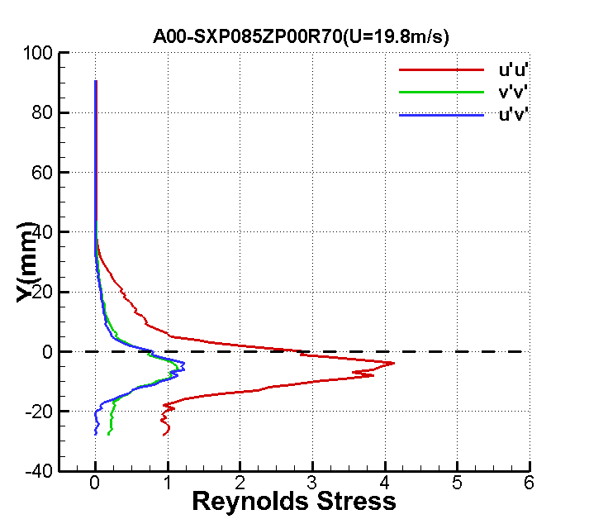

**X=4h**

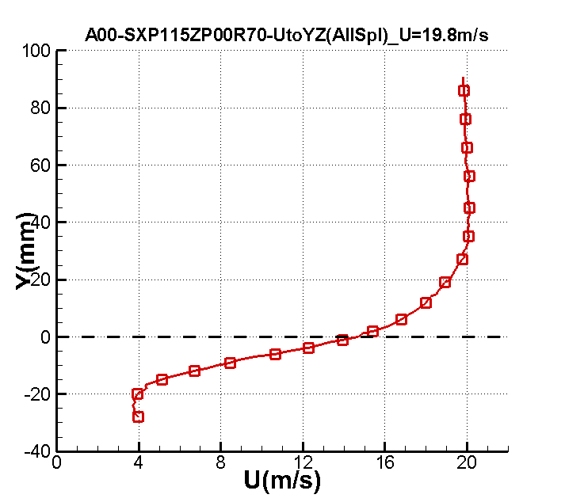

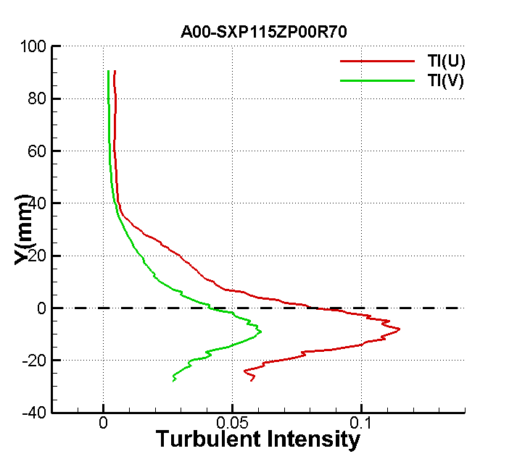

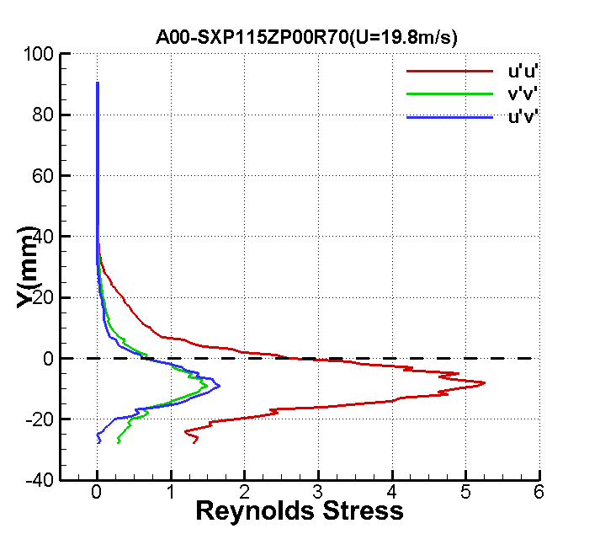

**X=5h**

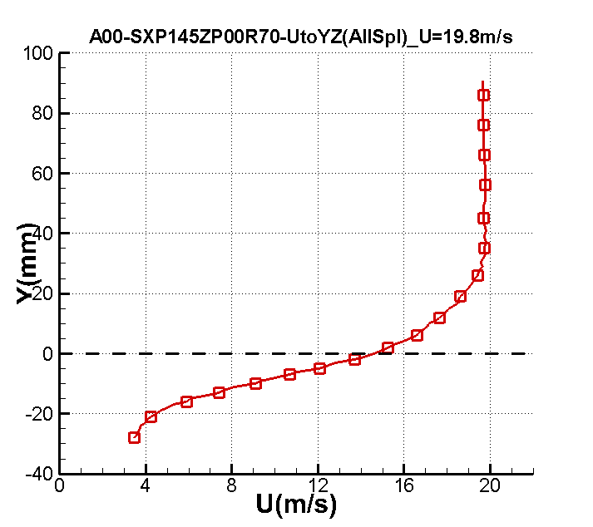

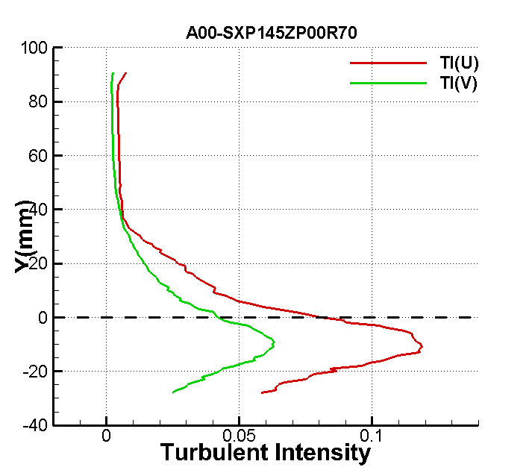

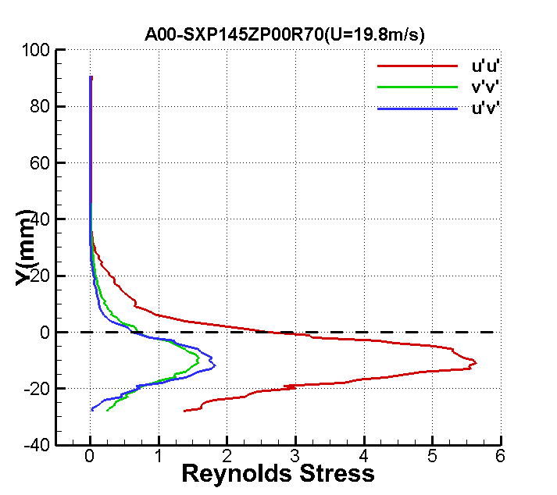

**X=6h**

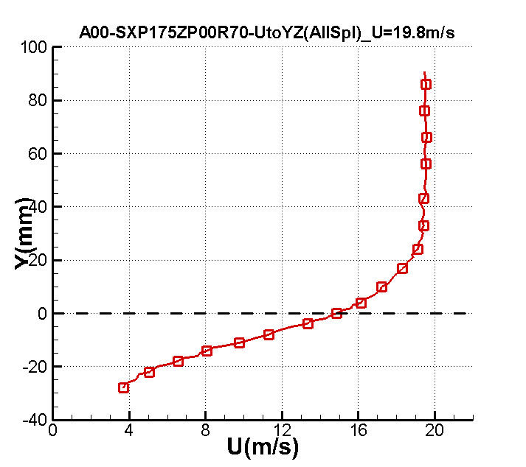

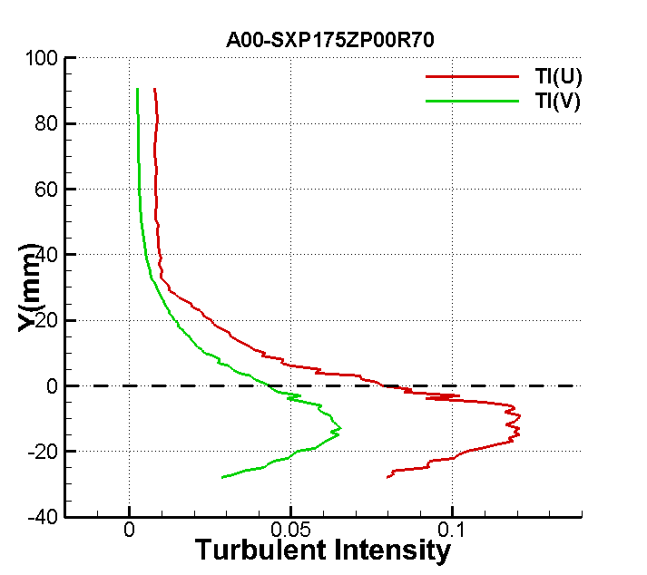

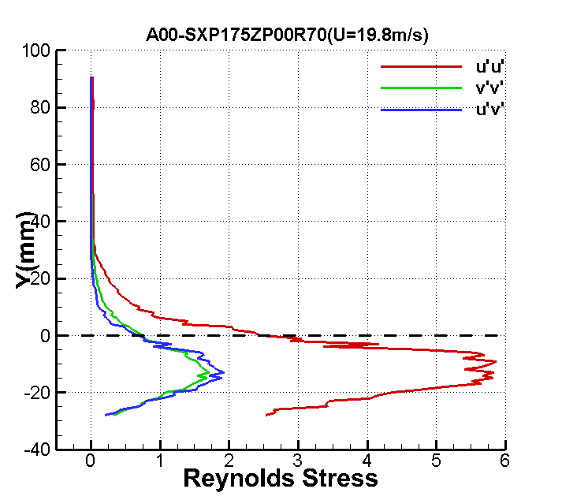

**X=7h**

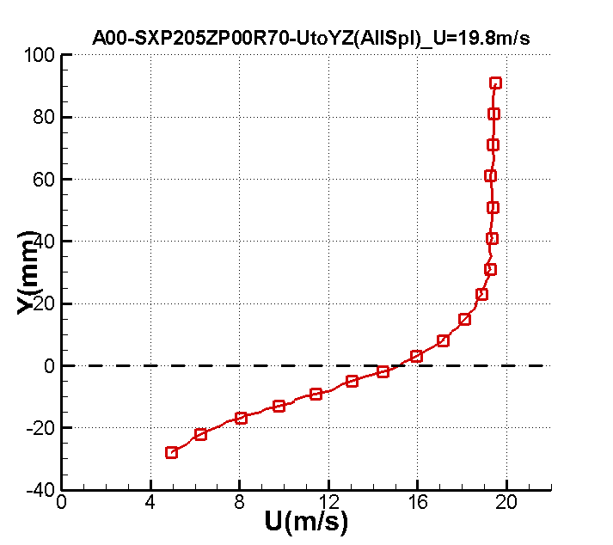

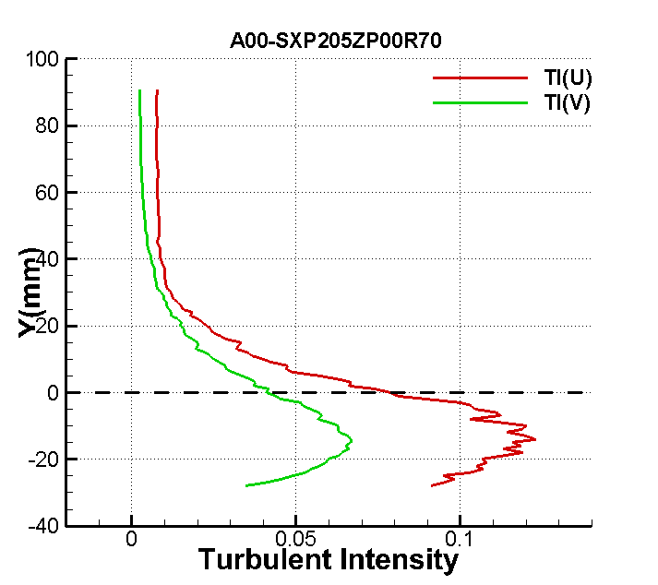

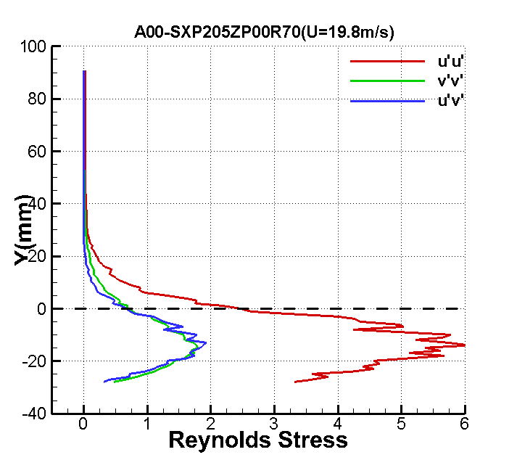

**X=8h**

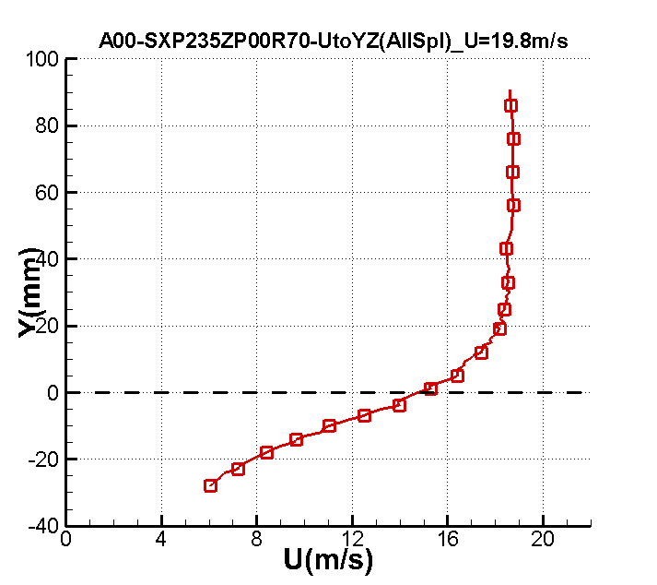

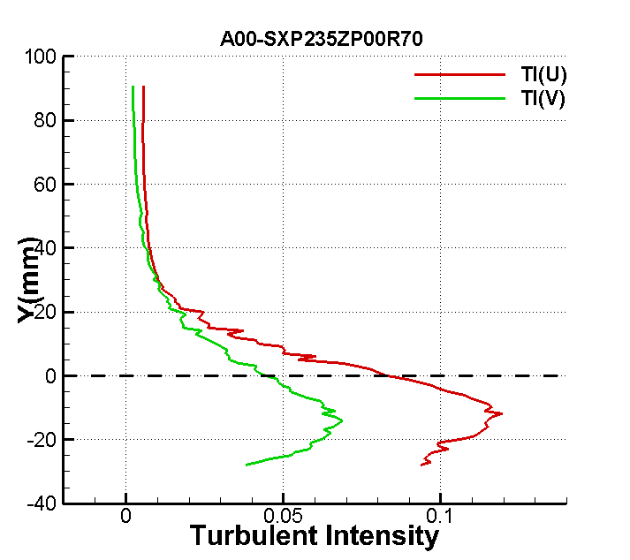

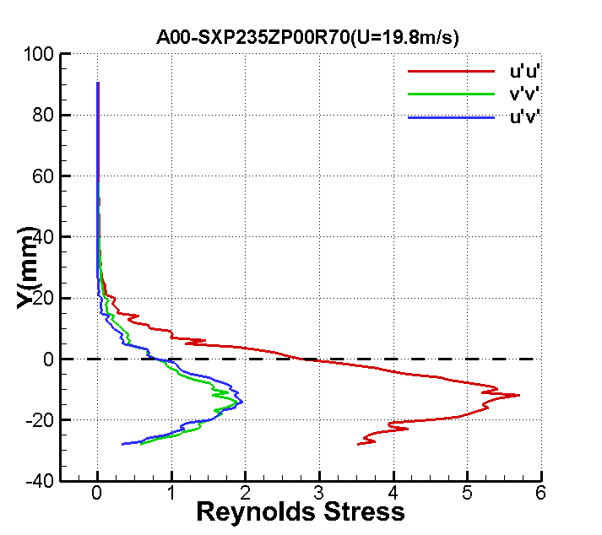

**X=9h**

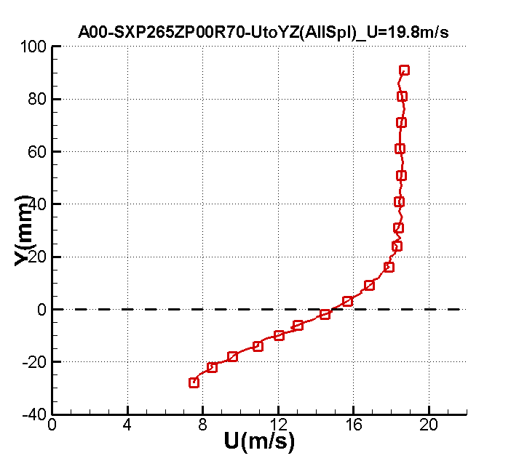

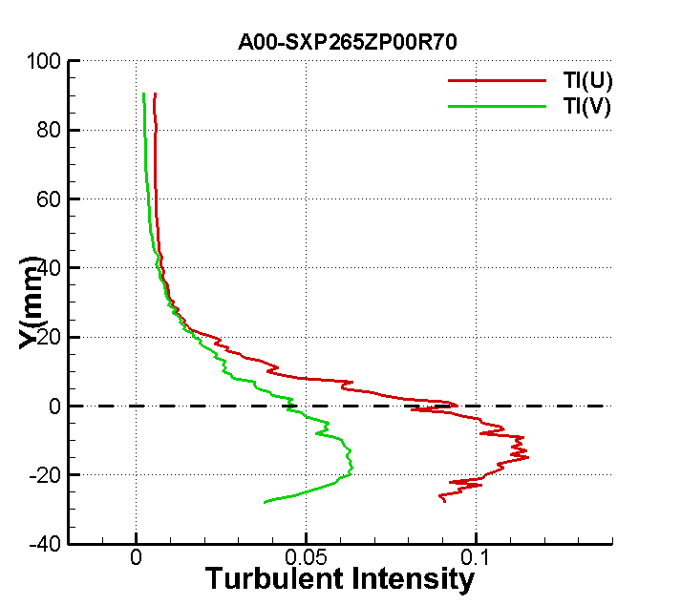

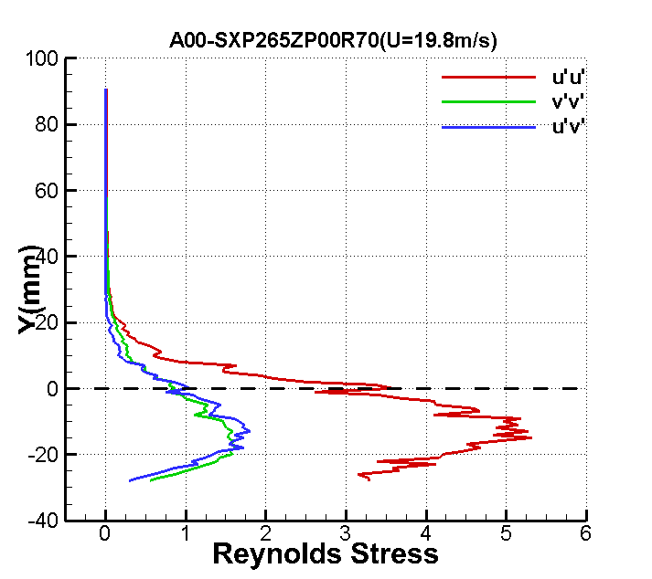

**X=10h**

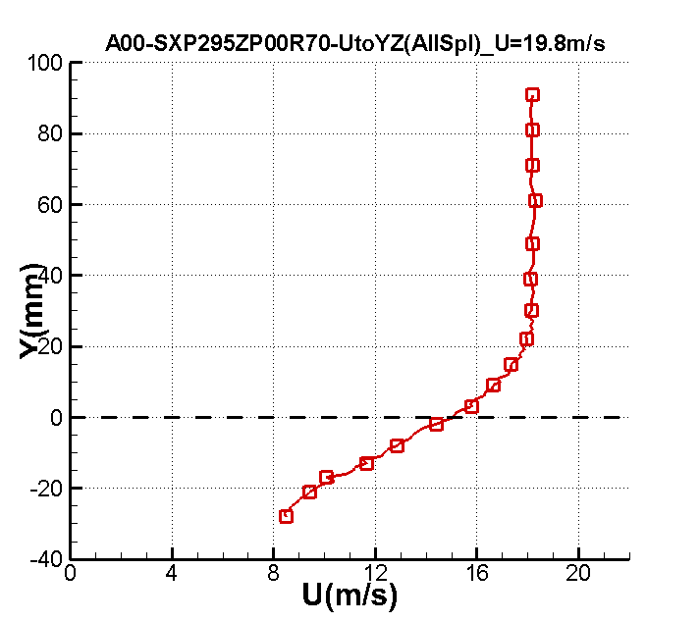

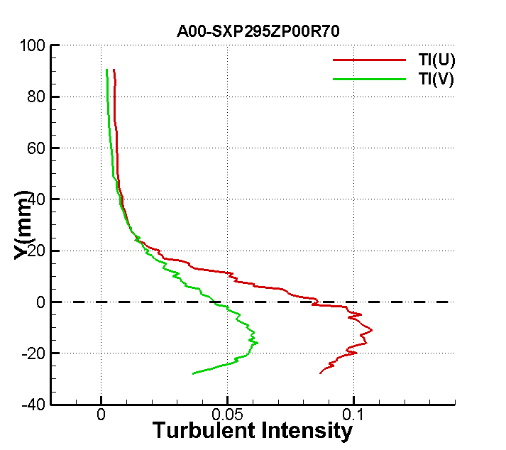

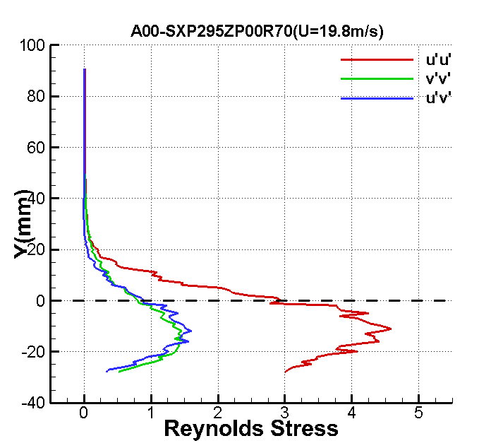

**BFS_ SJ_ EXP_CF_NUAA**

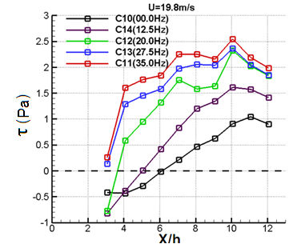

**BFS_ SJ_ EXP_TSS_NUAA**

**X/h=1**

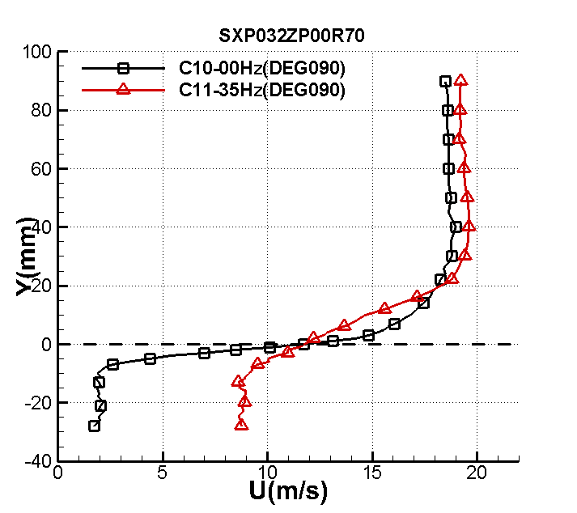 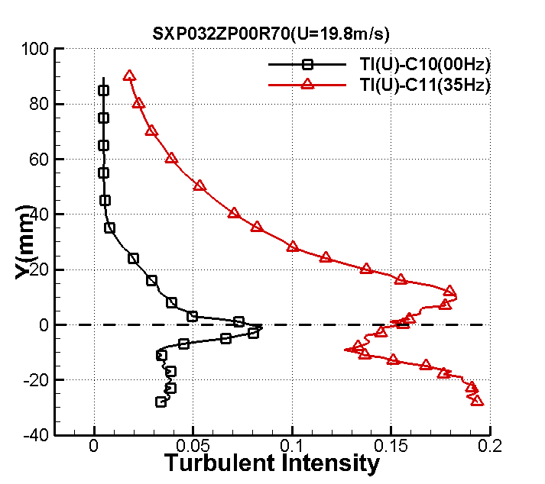

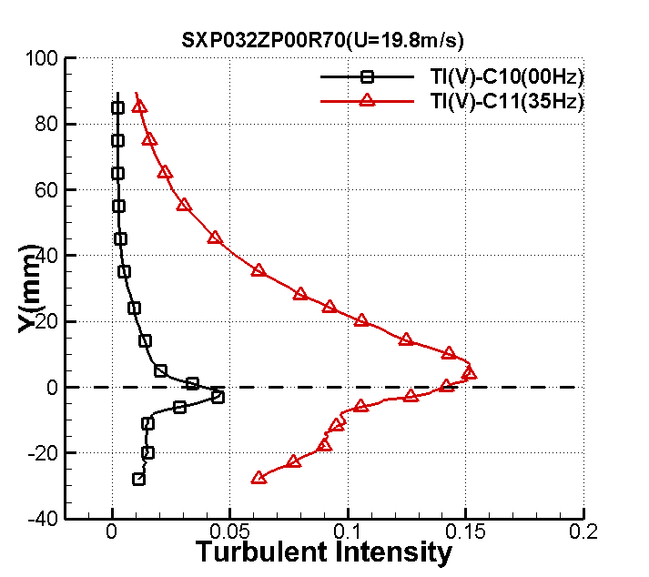 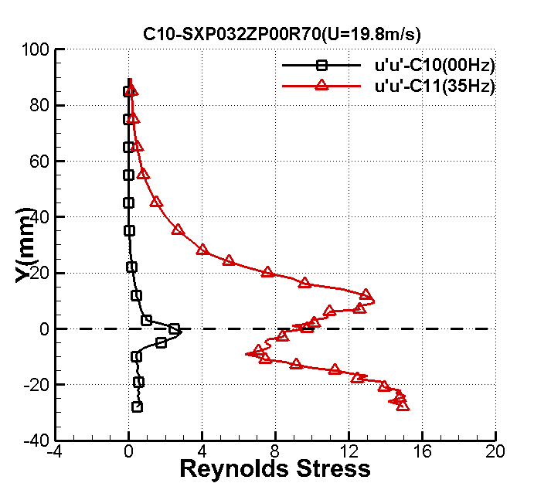

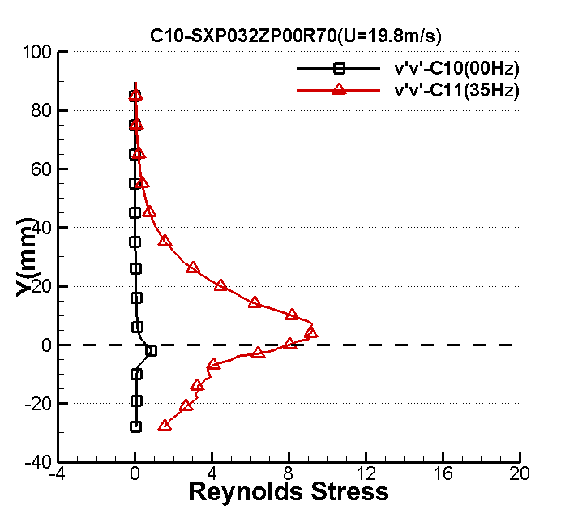 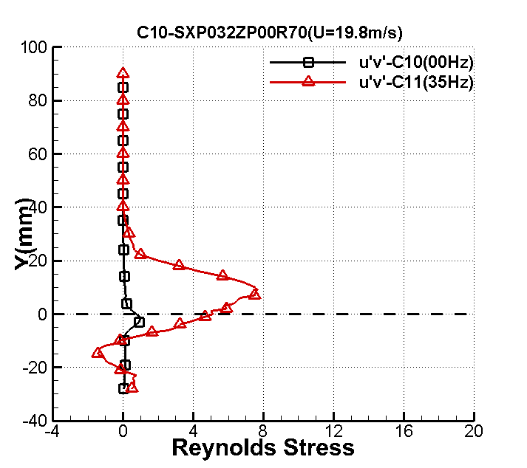

**X/h=3**

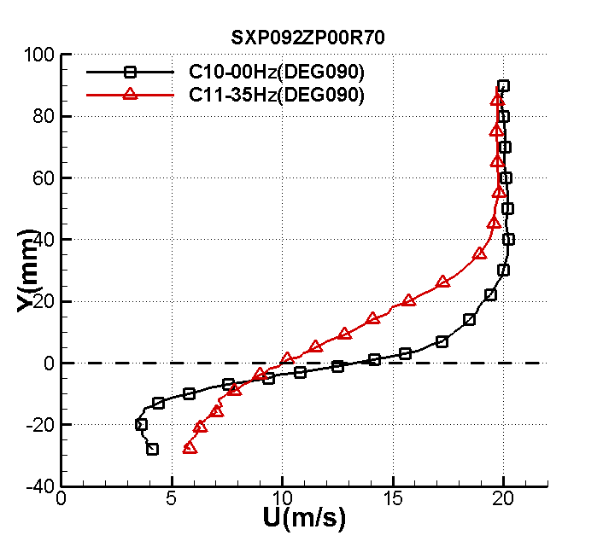 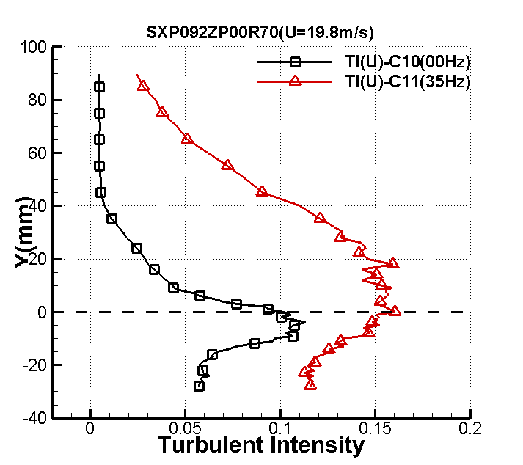

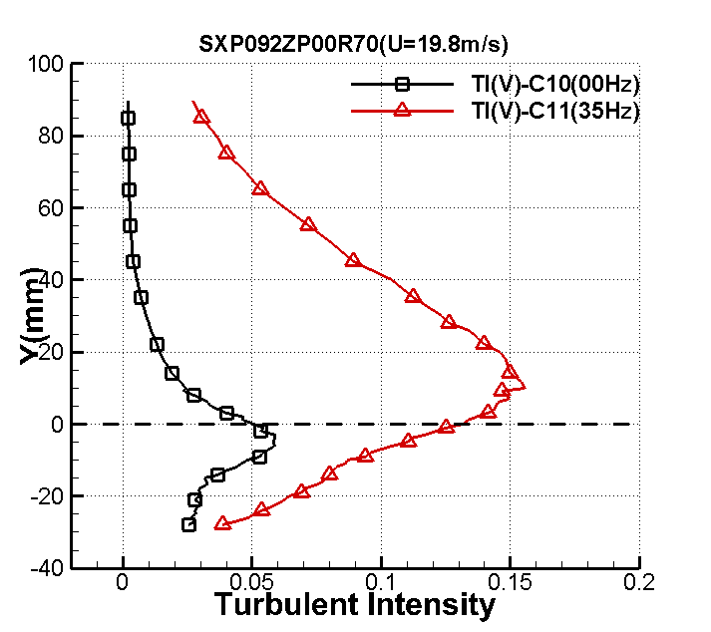 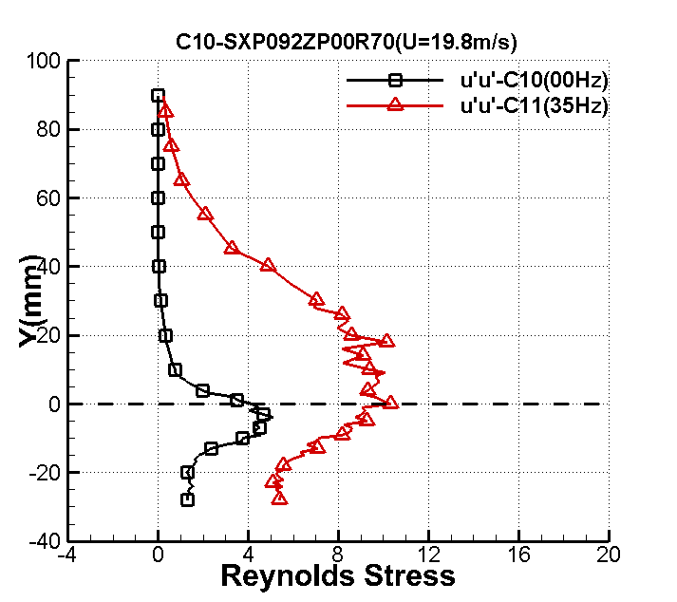

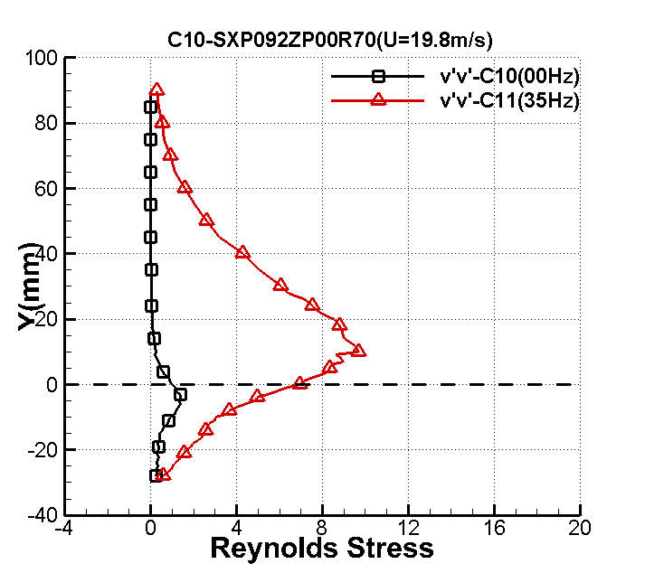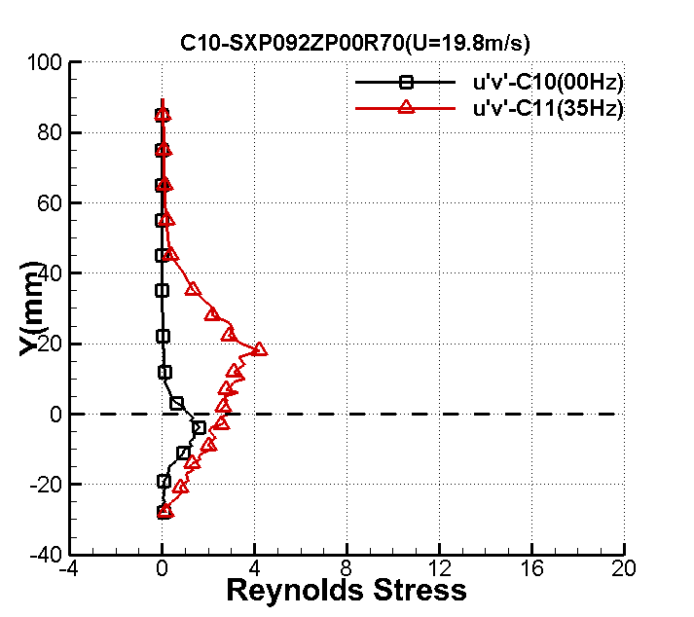

**X/h=7**

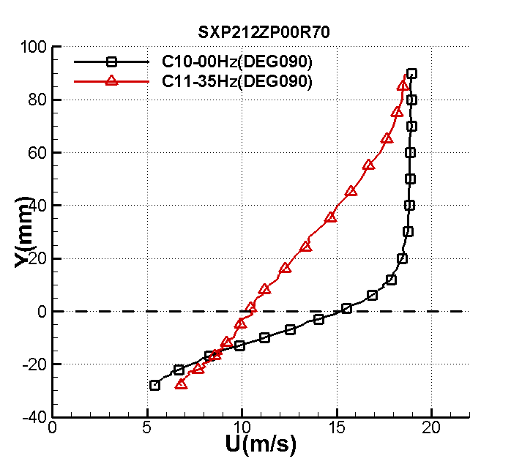 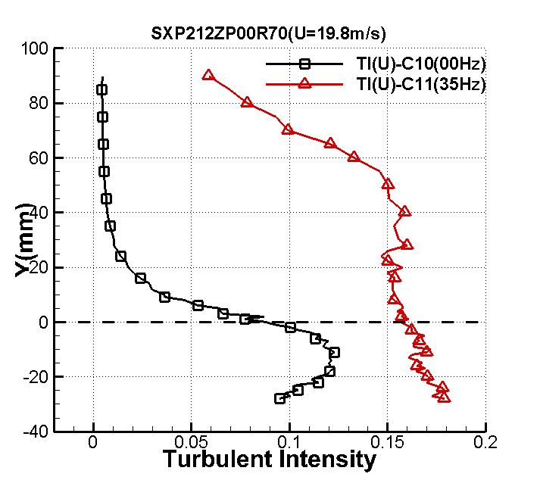

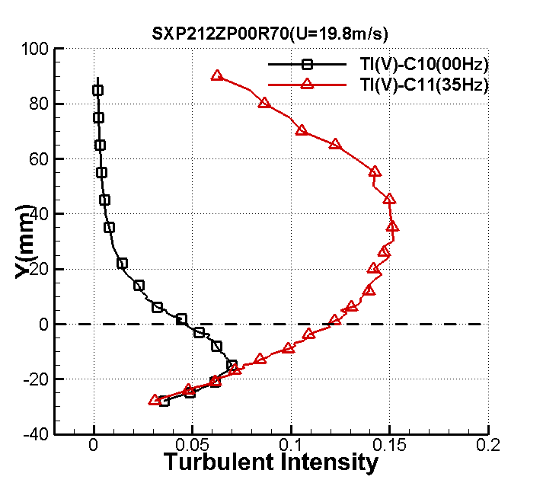 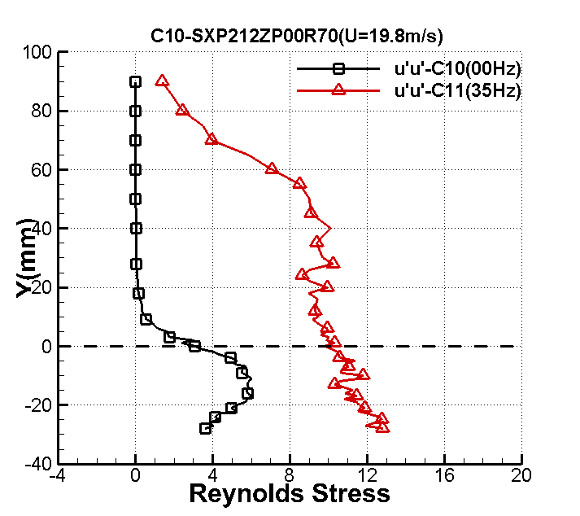

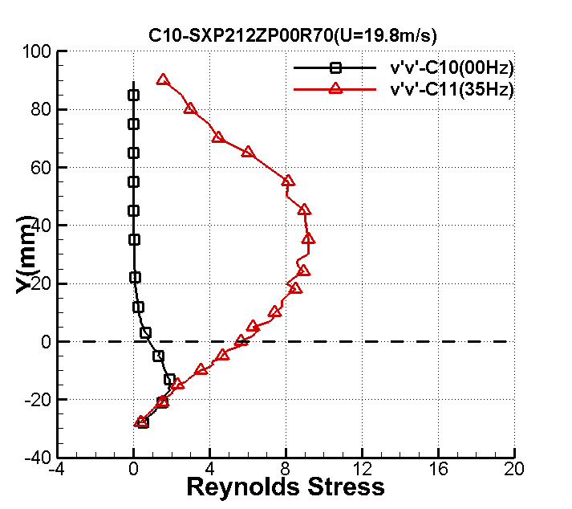 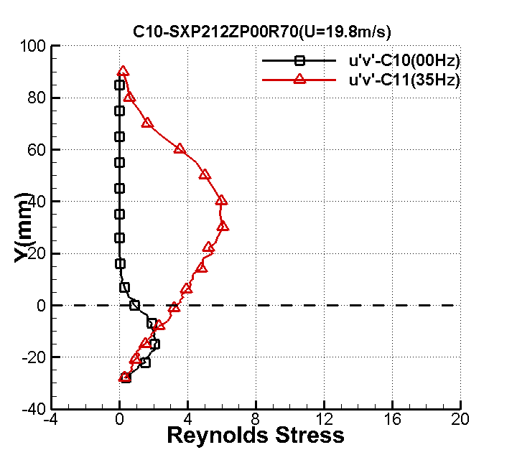

**X=10h**

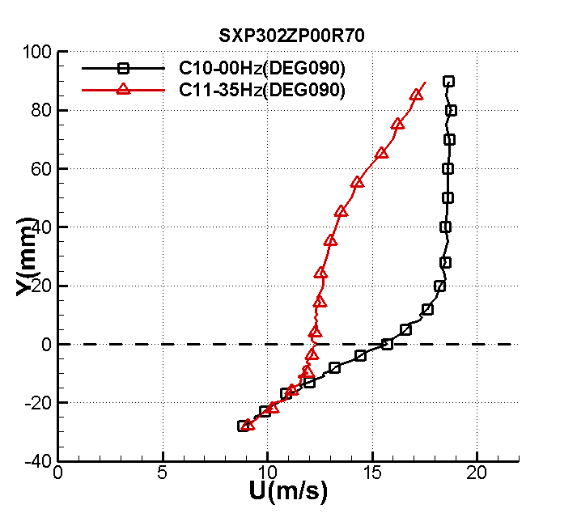 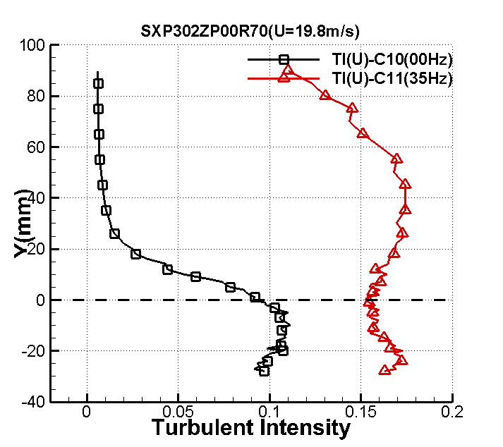

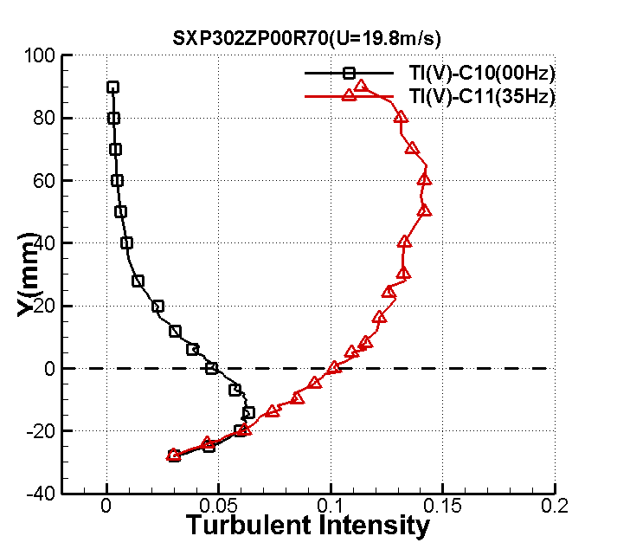 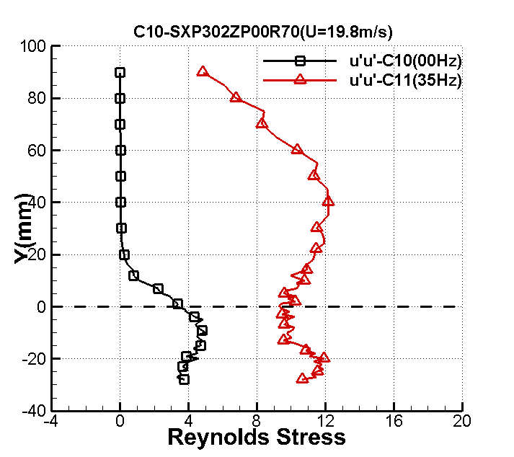

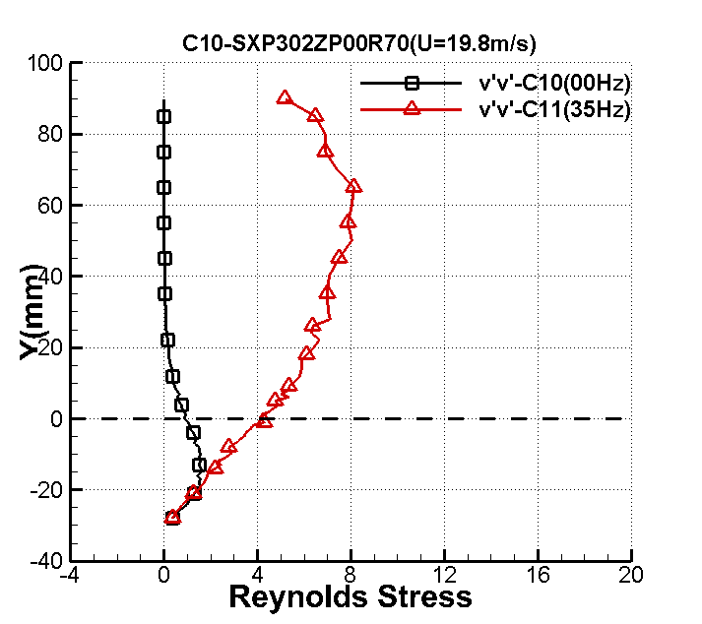 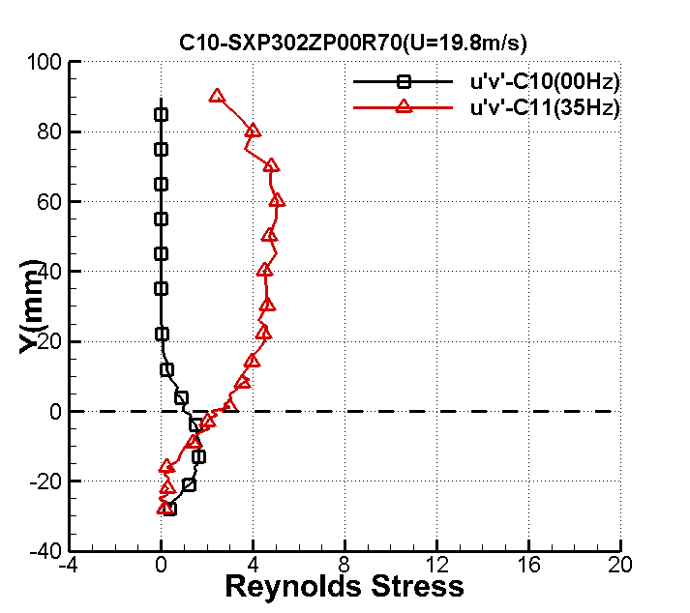

**EXPERIMENTAL DATA**

**BFS_ BL_ EXP_MCP_NUAA**

**Pressure coefficient**

1.0 -.180

2.0 -.188

3.0 -.189

4.0 -.154

5.0 -.011

6.0 -.023

7.0 .025

8.0 .032

9.0 .031

10.0 .028

11.0 .022

12.0 .015

13.0 .012

**BFS_ BL_ EXP_MSF_NUAA**

**Skin friction**

1.0 0.218

2.0 -0.040

3.0 -0.304

4.0 -0.508

5.0 -0.416

6.0 -0.044

7.0 0.274

8.0 0.485

9.0 0.750

10.0 0.776

11.0 1.033

12.0 0.817

13.0 0.897

**BFS_ BL_ EXP_TSS_NUAA**

**Profile of mean velocity, turbulence intensity, and Reynolds stresses**

**x/h=1**

y u T（u） T（v） uu vv uv

-28 1.546768 0.026719 0.010856 0.285568 0.047145 -0.000709

-27 1.561374 0.027053 0.010418 0.292745 0.043410 -0.005016

-26 1.628286 0.029995 0.010924 0.359890 0.047733 -0.017668

-25 1.765260 0.031874 0.011728 0.406369 0.055021 -0.004647

-24 1.793374 0.030425 0.012338 0.370266 0.060891 -0.005104

-23 1.666722 0.033282 0.011213 0.443088 0.050294 -0.014910

-22 1.778340 0.031729 0.011508 0.402692 0.052970 -0.024336

-21 1.718356 0.030758 0.010724 0.378412 0.045997 -0.009537

-20 1.835724 0.034710 0.011740 0.481916 0.055136 -0.043181

-19 1.908035 0.031203 0.011128 0.389446 0.049534 -0.039305

-18 1.805102 0.033080 0.012231 0.437707 0.059843 -0.050984

-17 1.811734 0.031365 0.011866 0.393493 0.056318 -0.047915

-16 1.900317 0.031350 0.011623 0.393135 0.054038 -0.058331

-15 1.877537 0.035538 0.012770 0.505173 0.065226 -0.060357

-14 1.858204 0.034570 0.011997 0.478044 0.057570 -0.057499

-13 1.955382 0.031652 0.012969 0.400732 0.067278 -0.078645

-12 1.862972 0.030058 0.011813 0.361403 0.055823 -0.062242

-11 1.818255 0.031951 0.012287 0.408344 0.060392 -0.074517

-10 1.891201 0.032737 0.012523 0.428693 0.062729 -0.088415

-9 1.941492 0.031937 0.013460 0.407977 0.072474 -0.073463

-8 1.829775 0.031731 0.012856 0.402750 0.066114 -0.059135

-7 1.835821 0.028426 0.012949 0.323205 0.067075 -0.045506

-6 2.124623 0.034099 0.016138 0.465085 0.104175 -0.056615

-5 2.626808 0.041239 0.022281 0.680262 0.198585 -0.152463

-4 3.705980 0.056370 0.031676 1.271045 0.401357 -0.347940

-3 5.246406 0.069046 0.040100 1.906922 0.643202 -0.608251

-2 7.375533 0.073519 0.045604 2.162032 0.831904 -0.777864

-1 9.361581 0.076322 0.045216 2.330018 0.817808 -0.781573

0 11.326505 0.074805 0.040487 2.238309 0.655672 -0.645154

1 13.008885 0.063889 0.031894 1.632737 0.406888 -0.373167

2 13.920048 0.056446 0.026832 1.274476 0.287985 -0.244984

3 14.469229 0.051325 0.023412 1.053707 0.219245 -0.199047

4 14.755242 0.052474 0.022375 1.101425 0.200264 -0.203761

5 15.112646 0.047397 0.021694 0.898596 0.188248 -0.195927

6 15.431596 0.049405 0.019924 0.976325 0.158790 -0.185478

7 15.759193 0.047399 0.019764 0.898648 0.156240 -0.178668

8 15.922691 0.046543 0.019481 0.866502 0.151805 -0.173469

9 16.261740 0.044656 0.018812 0.797661 0.141555 -0.163134

10 16.415917 0.045128 0.019424 0.814616 0.150923 -0.180776

11 16.806207 0.044001 0.018419 0.774427 0.135700 -0.169690

12 16.777616 0.042241 0.018008 0.713717 0.129716 -0.156020

13 17.055974 0.041583 0.018085 0.691644 0.130823 -0.150667

14 17.192547 0.039673 0.017467 0.629568 0.122045 -0.133635

15 17.380397 0.040523 0.017550 0.656836 0.123197 -0.143985

16 17.598949 0.038516 0.016935 0.593394 0.114714 -0.130950

17 17.802098 0.035965 0.016358 0.517396 0.107038 -0.118345

18 17.879073 0.037738 0.016048 0.569673 0.103018 -0.122477

19 17.945729 0.034601 0.015460 0.478887 0.095608 -0.100760

20 18.185973 0.035553 0.015807 0.505604 0.099939 -0.114132

21 18.241020 0.032962 0.015008 0.434608 0.090093 -0.095077

22 18.448711 0.031800 0.014025 0.404494 0.078680 -0.080193

23 18.584044 0.030947 0.013535 0.383083 0.073280 -0.074799

24 18.811622 0.029956 0.013300 0.358934 0.070754 -0.076531

25 18.927644 0.027893 0.012367 0.311213 0.061176 -0.058061

26 18.967689 0.025741 0.011801 0.265031 0.055709 -0.053007

27 19.122530 0.024403 0.011075 0.238199 0.049065 -0.043462

28 19.157112 0.023945 0.010994 0.229338 0.048350 -0.044686

29 19.254690 0.022947 0.010465 0.210626 0.043808 -0.037707

30 19.323824 0.020824 0.009751 0.173457 0.038030 -0.029963

31 19.400059 0.019838 0.009479 0.157414 0.035939 -0.028221

33 19.642599 0.016474 0.008235 0.108563 0.027123 -0.016061

35 19.655533 0.012825 0.007038 0.065790 0.019812 -0.008747

37 19.740633 0.009836 0.006129 0.038697 0.015025 -0.002815

39 19.676174 0.007505 0.005295 0.022528 0.011217 -0.000631

41 19.758959 0.006161 0.004678 0.015184 0.008752 0.0006010

43 19.763398 0.005679 0.004098 0.012901 0.006716 0.001050

45 19.652269 0.005403 0.003755 0.011679 0.005641 0.001844

47 19.762713 0.004788 0.003345 0.009170 0.004476 0.001548

49 19.808711 0.004747 0.003046 0.009013 0.003712 0.001700

51 19.792036 0.004413 0.002947 0.007788 0.003473 0.001446

56 19.741378 0.004539 0.002476 0.008242 0.002451 0.001546

61 19.647374 0.004180 0.002188 0.006990 0.001915 0.001340

66 19.703300 0.004217 0.002078 0.007112 0.001728 0.001439

71 19.673443 0.004293 0.002028 0.007373 0.001645 0.001550

76 19.587975 0.004252 0.002010 0.007232 0.001616 0.001544

81 19.556731 0.004090 0.001943 0.006691 0.001510 0.001543

86 19.508267 0.004152 0.001902 0.006895 0.001447 0.001302

91 19.528817 0.004037 0.001921 0.006519 0.001477 0.001343

**x/h=2**

-28 2.448970 0.043835 0.015600 0.768616 0.097340 -0.056572

-27 2.323112 0.040686 0.015575 0.662139 0.097038 -0.054413

-26 2.447255 0.041635 0.016025 0.693388 0.102715 -0.049052

-25 2.402093 0.041917 0.016102 0.702803 0.103714 -0.048015

-24 2.417352 0.043904 0.017045 0.771029 0.116210 -0.041378

-23 2.533528 0.043141 0.017547 0.744463 0.123158 -0.091235

-22 2.471454 0.043633 0.017106 0.761522 0.117044 -0.074751

-21 2.230013 0.039734 0.016259 0.631501 0.105741 -0.046063

-20 2.333648 0.042722 0.017831 0.730076 0.127182 -0.074022

-19 2.268536 0.040987 0.016209 0.671980 0.105088 -0.070504

-18 2.162298 0.038578 0.015385 0.595299 0.094681 -0.058392

-17 2.245813 0.039402 0.016565 0.621015 0.109760 -0.065867

-16 2.029998 0.035564 0.015377 0.505928 0.094577 -0.053667

-15 2.158871 0.038956 0.017200 0.607040 0.118343 -0.073024

-14 2.105245 0.037510 0.016874 0.562802 0.113890 -0.060885

-13 2.345948 0.040794 0.019046 0.665656 0.145102 -0.089976

-12 2.430815 0.041327 0.020810 0.683179 0.173228 -0.125287

-11 2.699019 0.053553 0.024521 1.147191 0.240503 -0.225436

-10 2.993555 0.053328 0.027456 1.137532 0.301523 -0.274608

-9 3.377770 0.060262 0.030608 1.452607 0.374740 -0.365258

-8 4.195532 0.074479 0.036763 2.218838 0.540597 -0.593019

-7 4.510977 0.071988 0.038257 2.072898 0.585451 -0.575372

-6 5.787002 0.086963 0.045650 3.024999 0.833583 -0.930544

-5 6.744192 0.085391 0.046030 2.916669 0.847520 -0.898462

-4 7.535108 0.091484 0.048833 3.347700 0.953873 -1.038644

-3 8.745468 0.090011 0.049841 3.240797 0.993643 -0.986454

-2 9.702377 0.097855 0.049799 3.830272 0.991965 -1.138358

-1 10.915617 0.092250 0.045461 3.403993 0.826685 -0.923238

0 12.159997 0.080324 0.041117 2.580800 0.676248 -0.757204

1 12.950073 0.077076 0.038393 2.376302 0.589602 -0.637512

2 13.885953 0.069933 0.033722 1.956271 0.454858 -0.448410

3 14.348904 0.065778 0.031623 1.730703 0.399996 -0.375259

4 14.891503 0.054706 0.027131 1.197117 0.294444 -0.245898

5 15.304461 0.052914 0.026946 1.119951 0.290444 -0.265013

6 15.780743 0.049237 0.023918 0.969709 0.228821 -0.181931

7 15.830682 0.047334 0.023362 0.896212 0.218313 -0.175724

8 16.163377 0.045530 0.022356 0.829186 0.199924 -0.173246

9 16.242643 0.044290 0.020995 0.784632 0.176311 -0.159734

10 16.515031 0.042892 0.019935 0.735904 0.158961 -0.147178

11 16.715710 0.042452 0.019028 0.720862 0.144829 -0.141545

12 16.794451 0.041112 0.019140 0.676079 0.146532 -0.143922

13 17.102955 0.039934 0.018315 0.637888 0.134175 -0.128598

14 17.253119 0.039679 0.018142 0.629763 0.131647 -0.136138

15 17.470069 0.036719 0.016833 0.539327 0.113336 -0.112163

16 17.586507 0.036505 0.016599 0.533040 0.110216 -0.106708

17 17.668312 0.035958 0.016748 0.517197 0.112203 -0.115154

18 17.961036 0.034090 0.015465 0.464844 0.095668 -0.101048

19 18.039387 0.034348 0.015327 0.471920 0.093972 -0.099737

20 18.196613 0.033316 0.014754 0.443991 0.087074 -0.091529

21 18.256989 0.030429 0.014099 0.370365 0.079517 -0.077491

22 18.354546 0.030769 0.014044 0.378699 0.078891 -0.076602

23 18.524242 0.030065 0.013099 0.361570 0.068637 -0.068851

24 18.734107 0.027858 0.012710 0.310420 0.064620 -0.057670

25 18.753553 0.026743 0.011990 0.286066 0.057505 -0.050660

26 18.820268 0.024320 0.011784 0.236578 0.055545 -0.049119

27 19.047252 0.022806 0.010734 0.208039 0.046086 -0.035613

28 19.113736 0.021591 0.010542 0.186466 0.044449 -0.034740

29 19.187496 0.022077 0.010082 0.194951 0.040659 -0.032578

30 19.333146 0.018966 0.009309 0.143876 0.034667 -0.024478

31 19.421488 0.018556 0.008855 0.137731 0.031361 -0.022848

33 19.555413 0.013164 0.007571 0.069318 0.022928 -0.009545

35 19.591335 0.011753 0.006964 0.055250 0.019399 -0.006907

37 19.623909 0.008547 0.006053 0.029224 0.014655 -0.001592

39 19.635123 0.006600 0.005039 0.017423 0.010158 -0.000461

41 19.588663 0.005921 0.004557 0.014024 0.008305 0.000682

43 19.651153 0.005009 0.003980 0.010038 0.006336 0.001000

45 19.579921 0.004893 0.003695 0.009576 0.005462 0.001181

47 19.609506 0.004634 0.003432 0.008589 0.004711 0.001599

49 19.580070 0.004758 0.003081 0.009055 0.003797 0.001964

51 19.591128 0.004529 0.002967 0.008206 0.003520 0.001775

56 19.533875 0.004592 0.002636 0.008433 0.002779 0.002006

61 19.551092 0.004294 0.002344 0.007377 0.002198 0.001605

66 19.449949 0.004389 0.002171 0.007704 0.001885 0.001902

71 19.427192 0.004217 0.002121 0.007113 0.001800 0.001805

76 19.453237 0.004166 0.002081 0.006943 0.001733 0.001622

81 19.368856 0.004001 0.001941 0.006404 0.001507 0.001463

86 19.404386 0.003999 0.001938 0.006398 0.001502 0.001531

91 19.305875 0.004281 0.002062 0.007330 0.001701 0.001845

**x/h=3**

-28 3.386572 0.048481 0.021252 0.940144 0.180653 0.003299

-27 3.238413 0.049775 0.021368 0.991003 0.182644 -0.015268

-26 3.210371 0.050317 0.024142 1.012727 0.233134 -0.004468

-25 3.175700 0.050476 0.023529 1.019147 0.221453 -0.039408

-24 3.141962 0.049637 0.023291 0.985517 0.216980 -0.040949

-23 2.936089 0.047552 0.023127 0.904477 0.213950 -0.007264

-22 3.094960 0.049561 0.024184 0.982504 0.233941 -0.015779

-21 2.885805 0.048086 0.023169 0.924891 0.214724 -0.004683

-20 3.043579 0.049278 0.024565 0.971326 0.241377 -0.011667

-19 3.050103 0.052422 0.025265 1.099237 0.255338 -0.086200

-18 3.030030 0.048371 0.026171 0.935913 0.273978 -0.068225

-17 3.069778 0.052934 0.024344 1.120814 0.237048 -0.136469

-16 3.137540 0.054865 0.028123 1.204057 0.316351 -0.253579

-15 3.446151 0.060573 0.030514 1.467658 0.372442 -0.337351

-14 3.785377 0.066257 0.034371 1.755988 0.472548 -0.452490

-13 3.951234 0.075048 0.035739 2.252897 0.510917 -0.506793

-12 4.345093 0.077507 0.038460 2.402905 0.591656 -0.641093

-11 5.231331 0.082557 0.043690 2.726259 0.763511 -0.820861

-10 5.584453 0.087468 0.045826 3.060277 0.839999 -0.899998

-9 6.176361 0.092707 0.050017 3.437831 1.000681 -1.038537

-8 6.904223 0.098057 0.051269 3.846091 1.051389 -1.144853

-7 7.819338 0.094154 0.050770 3.545977 1.031034 -1.040964

-6 8.416866 0.098092 0.053302 3.848778 1.136439 -1.228516

-5 9.299771 0.099316 0.053053 3.945441 1.125832 -1.188631

-4 10.219813 0.101625 0.051777 4.131039 1.072328 -1.237337

-3 11.006040 0.097243 0.049979 3.782507 0.999161 -1.093592

-2 11.921137 0.090447 0.045840 3.272233 0.840526 -0.905209

-1 12.771360 0.084028 0.042641 2.824309 0.727299 -0.789251

0 13.146689 0.085165 0.043520 2.901226 0.757610 -0.801770

1 13.797548 0.077222 0.039424 2.385274 0.621710 -0.620069

2 14.386603 0.070852 0.035361 2.008015 0.500167 -0.477882

3 14.851155 0.062943 0.032405 1.584710 0.420038 -0.360666

4 15.308920 0.059130 0.029176 1.398547 0.340489 -0.292280

5 15.645656 0.050990 0.026931 1.040004 0.290121 -0.223411

6 15.860753 0.049697 0.027023 0.987918 0.292098 -0.219485

7 16.047444 0.047676 0.025287 0.909196 0.255769 -0.196599

8 16.301131 0.044593 0.023660 0.795406 0.223924 -0.173561

9 16.527983 0.041589 0.022585 0.691861 0.204028 -0.140917

10 16.677912 0.042165 0.021272 0.711147 0.180993 -0.143857

11 16.884030 0.041221 0.020347 0.679664 0.165593 -0.139720

12 17.031260 0.040187 0.019319 0.645992 0.149287 -0.137623

13 17.256202 0.036957 0.018767 0.546323 0.140883 -0.113322

14 17.370530 0.037735 0.018101 0.569580 0.131052 -0.117441

15 17.352570 0.036097 0.017506 0.521205 0.122581 -0.106546

16 17.604091 0.035555 0.017395 0.505660 0.121028 -0.103300

17 17.833154 0.034173 0.015672 0.467128 0.098248 -0.088273

18 17.844807 0.031687 0.015393 0.401622 0.094777 -0.079250

19 18.016713 0.031917 0.015150 0.407468 0.091805 -0.084404

20 18.004348 0.029945 0.014285 0.358690 0.081622 -0.075959

21 18.247154 0.030147 0.013845 0.363533 0.076669 -0.064275

22 18.387245 0.028342 0.013358 0.321299 0.071373 -0.059698

23 18.483161 0.026582 0.012239 0.282649 0.059917 -0.051809

24 18.569906 0.025249 0.011491 0.255013 0.052817 -0.041657

25 18.671701 0.023791 0.011181 0.226406 0.050002 -0.035970

26 18.789107 0.023497 0.010985 0.220842 0.048265 -0.040237

27 18.888510 0.020329 0.010025 0.165306 0.040197 -0.023558

28 19.001348 0.019765 0.009888 0.156270 0.039105 -0.026315

29 19.022040 0.017817 0.008964 0.126973 0.032141 -0.018060

30 19.031032 0.016036 0.008633 0.102858 0.029813 -0.012678

31 19.091294 0.014411 0.008057 0.083069 0.025964 -0.009368

33 19.261819 0.011798 0.007171 0.055678 0.020568 -0.004001

35 19.377127 0.009276 0.006504 0.034419 0.016920 -0.002751

37 19.292343 0.007318 0.005433 0.021419 0.011809 0.0007840

39 19.255933 0.005964 0.004778 0.014226 0.009132 0.0012700

41 19.246553 0.005452 0.004250 0.011890 0.007227 0.0016520

43 19.240234 0.005346 0.004043 0.011431 0.006538 0.0020710

45 19.289446 0.004951 0.003668 0.009804 0.005383 0.002070

47 19.264064 0.004796 0.003348 0.009200 0.004483 0.002189

49 19.269356 0.004962 0.003134 0.009848 0.003929 0.002459

51 19.044937 0.004480 0.002925 0.008029 0.003423 0.001933

56 19.142445 0.004355 0.002512 0.007586 0.002524 0.001909

61 19.165061 0.004412 0.002391 0.007788 0.002288 0.001994

66 19.150396 0.004603 0.002283 0.008476 0.002084 0.002122

71 19.064480 0.004456 0.002245 0.007944 0.002016 0.002202

76 19.034704 0.004361 0.002149 0.007608 0.001847 0.002009

81 19.014866 0.004214 0.002047 0.007102 0.001677 0.001652

86 19.035879 0.004285 0.002056 0.007345 0.001691 0.001890

91 19.045868 0.004123 0.002077 0.006798 0.001726 0.001764 **x/h=4**

-283.966952 0.057291 0.026856 1.312899 0.288493-0.022673

-27 3.856921 0.057812 0.027936 1.336892 0.312170 -0.047891

-26 3.768498 0.058614 0.026948 1.374263 0.290470 -0.027350

-25 3.788346 0.055257 0.028603 1.221346 0.327257 -0.003326

-24 3.714152 0.054403 0.030001 1.183885 0.360024 -0.081128

-23 3.800196 0.059094 0.031637 1.396828 0.400369 -0.101632

-22 3.777145 0.062182 0.033762 1.546623 0.455960 -0.148212

-21 3.849921 0.061677 0.032672 1.521643 0.426975 -0.195418

-20 3.937404 0.069299 0.034023 1.920960 0.463022 -0.244597

-19 4.161338 0.073784 0.039445 2.177604 0.622348 -0.462263

-18 4.403819 0.078327 0.041760 2.454044 0.697571 -0.567355

-17 4.315162 0.076549 0.039479 2.343872 0.623450 -0.512589

-16 4.640225 0.087949 0.042996 3.094017 0.739461 -0.819254

-15 5.127875 0.094556 0.048373 3.576309 0.935990 -1.080361

-14 5.464240 0.100103 0.050306 4.008219 1.012286 -1.193949

-13 6.110087 0.101489 0.053686 4.120007 1.152886 -1.282646

-12 6.707890 0.109032 0.056384 4.755204 1.271642 -1.426142

-11 7.287423 0.107467 0.058713 4.619630 1.378884 -1.515827

-10 7.830192 0.110543 0.059340 4.887909 1.408492 -1.582238

-9 8.452788 0.113504 0.061171 5.153257 1.496773 -1.668171

-8 8.914920 0.114690 0.059178 5.261507 1.400827 -1.588010

-7 9.680870 0.109739 0.059790 4.817016 1.429952 -1.579935

-6 10.635321 0.107650 0.055616 4.635410 1.237269 -1.344194

-5 11.294254 0.110815 0.056811 4.911961 1.290979 -1.382218

-4 12.281891 0.101865 0.052890 4.150615 1.118932 -1.191962

-3 12.710364 0.103460 0.050806 4.281579 1.032498 -1.168703

-2 13.260425 0.094586 0.050389 3.578584 1.015618 -0.995238

-1 13.954233 0.092429 0.045160 3.417276 0.815783 -0.836145

0 14.707805 0.080423 0.040542 2.587139 0.657471 -0.627600

1 14.857326 0.077841 0.041104 2.423710 0.675815 -0.596560

2 15.384577 0.070048 0.037651 1.962669 0.567028 -0.480853

3 15.920191 0.067619 0.034738 1.828942 0.482688 -0.400315

4 16.216929 0.060029 0.032820 1.441393 0.430856 -0.302830

5 16.538716 0.056344 0.029956 1.269853 0.358937 -0.272039

6 16.778602 0.054194 0.030512 1.174783 0.372387 -0.266485

7 16.981742 0.046972 0.027039 0.882538 0.292452 -0.169692

8 17.230742 0.045044 0.025526 0.811592 0.260627 -0.163997

9 17.501513 0.043119 0.023455 0.743711 0.220050 -0.140199

10 17.632241 0.042767 0.021885 0.731619 0.191573 -0.119871

11 17.876734 0.039513 0.020967 0.624511 0.175844 -0.112918

12 17.984738 0.038738 0.019448 0.600268 0.151283 -0.101319

13 18.125870 0.037350 0.019894 0.558004 0.158310 -0.093920

14 18.213592 0.036311 0.018298 0.527400 0.133924 -0.093964

15 18.514584 0.035179 0.017784 0.495029 0.126507 -0.091303

16 18.587815 0.033935 0.017091 0.460625 0.116845 -0.090526

17 18.735386 0.033291 0.015904 0.443313 0.101178 -0.075641

18 18.791890 0.031279 0.015643 0.391341 0.097884 -0.066725

19 18.935005 0.030185 0.015449 0.364452 0.095462 -0.069650

20 19.190257 0.029745 0.014553 0.353913 0.084714 -0.060873

21 19.246009 0.027641 0.013363 0.305619 0.071424 -0.050925

22 19.331022 0.025558 0.012750 0.261282 0.065020 -0.039455

23 19.395379 0.025229 0.011996 0.254601 0.057566 -0.036349

24 19.496074 0.022220 0.011382 0.197495 0.051818 -0.028652

25 19.549209 0.022323 0.011005 0.199325 0.048443 -0.028317

26 19.659773 0.020394 0.010515 0.166370 0.044230 -0.023521

27 19.756101 0.018192 0.009786 0.132378 0.038304 -0.017426

28 19.888771 0.015927 0.009263 0.101472 0.034325 -0.013141

29 19.799842 0.015055 0.008742 0.090660 0.030571 -0.008912

30 19.848905 0.013669 0.007968 0.074733 0.025394 -0.006611

31 19.946715 0.012084 0.007628 0.058408 0.023273 -0.004834

33 20.055601 0.010306 0.006893 0.042487 0.019007 -0.003970

35 20.066810 0.007771 0.005887 0.024156 0.013863 0.000310

37 20.019711 0.006757 0.005202 0.018261 0.010825 0.001003

39 20.095370 0.006261 0.004882 0.015681 0.009533 0.001063

41 20.039005 0.005607 0.004139 0.012573 0.006853 0.001685

43 20.169786 0.005514 0.003947 0.012161 0.006232 0.001968

45 20.126981 0.005284 0.003556 0.011167 0.005057 0.001423

47 20.091308 0.005228 0.003373 0.010934 0.004552 0.001721

49 20.050905 0.004833 0.003102 0.009344 0.003849 0.001443

51 20.003095 0.005039 0.002973 0.010156 0.003537 0.001617

56 20.126681 0.004559 0.002492 0.008312 0.002484 0.001191

61 19.930165 0.004173 0.002277 0.006965 0.002074 0.001146

66 20.010453 0.004278 0.002128 0.007320 0.001811 0.001228

71 19.894243 0.004330 0.002069 0.007500 0.001712 0.001258

76 19.932366 0.004772 0.002051 0.009109 0.001683 0.001479

81 19.934487 0.004550 0.001971 0.008280 0.001555 0.001484

86 19.838948 0.004221 0.001878 0.007126 0.001410 0.001289

91 19.797774 0.004332 0.001850 0.007506 0.001368 0.001334

**x/h=5**

-28 3.480279 0.058427 0.024830 1.365469 0.246602 -0.029541

-27 3.594468 0.063619 0.026147 1.618957 0.273473 -0.021993

-26 3.654479 0.063586 0.029553 1.617275 0.349352 -0.111936

-25 3.734845 0.064714 0.030396 1.675180 0.369556 -0.160121

-24 3.753370 0.067293 0.032727 1.811316 0.428419 -0.212443

-23 4.012579 0.075127 0.037067 2.257618 0.549575 -0.462553

-22 4.065197 0.076103 0.035909 2.316662 0.515781 -0.440111

-21 4.255226 0.078337 0.040193 2.454679 0.646206 -0.593757

-20 4.504230 0.086662 0.042542 3.004105 0.723912 -0.730262

-19 4.675997 0.084055 0.043560 2.826109 0.758978 -0.671213

-18 5.021826 0.096314 0.048503 3.710527 0.941004 -1.066342

-17 5.328204 0.098907 0.051705 3.913074 1.069365 -1.201468

-16 5.913640 0.104038 0.055860 4.329560 1.248140 -1.401151

-15 6.059991 0.107552 0.055477 4.627004 1.231071 -1.503685

-14 6.694519 0.110051 0.058963 4.844524 1.390632 -1.574898

-13 7.409876 0.117878 0.060086 5.558111 1.444141 -1.766079

-12 7.739458 0.117586 0.061254 5.530624 1.500807 -1.829551

-11 8.132820 0.118744 0.062705 5.640095 1.572791 -1.786959

-10 9.100031 0.118328 0.062547 5.600603 1.564830 -1.732760

-9 9.321791 0.116826 0.063071 5.459284 1.591164 -1.778564

-8 10.045833 0.115889 0.062298 5.372131 1.552431 -1.689596

-7 10.681859 0.114996 0.059791 5.289600 1.430005 -1.608733

-6 11.068256 0.115122 0.058951 5.301190 1.390085 -1.580339

-5 12.066723 0.112037 0.056738 5.020890 1.287684 -1.405872

-4 12.511406 0.105380 0.054640 4.441942 1.194228 -1.227287

-3 12.864442 0.102416 0.053174 4.195599 1.130982 -1.228199

-2 13.717188 0.089982 0.046887 3.238708 0.879353 -0.863902

-1 14.183810 0.089453 0.044029 3.200771 0.775423 -0.769698

0 14.614138 0.080266 0.041690 2.577040 0.695238 -0.621401

1 14.959524 0.075463 0.041011 2.277875 0.672747 -0.574092

2 15.240318 0.070849 0.040411 2.007827 0.653226 -0.527332

3 15.576252 0.064349 0.034764 1.656340 0.483403 -0.384827

4 15.919877 0.058809 0.033027 1.383418 0.436305 -0.296793

5 16.263768 0.054430 0.031591 1.185056 0.399184 -0.251068

6 16.597228 0.049035 0.027626 0.961758 0.305271 -0.192477

7 16.678844 0.047458 0.028108 0.900910 0.316020 -0.187930

8 16.907460 0.044715 0.025814 0.799763 0.266551 -0.147577

9 17.105900 0.040392 0.025041 0.652590 0.250824 -0.135591

10 17.157382 0.040756 0.022857 0.664418 0.208984 -0.124267

11 17.497200 0.040790 0.023359 0.665531 0.218251 -0.124410

12 17.656427 0.039058 0.021686 0.610223 0.188110 -0.115008

13 17.805892 0.036885 0.019899 0.544194 0.158387 -0.103999

14 17.995648 0.034952 0.019303 0.488662 0.149043 -0.087830

15 18.080580 0.033585 0.018647 0.451177 0.139086 -0.085675

16 18.352381 0.032745 0.017299 0.428899 0.119705 -0.077770

17 18.531277 0.030067 0.016168 0.361611 0.104567 -0.060639

18 18.529980 0.029793 0.015655 0.355054 0.098034 -0.059036

19 18.590488 0.029788 0.015075 0.354932 0.090899 -0.064105

20 18.768010 0.026795 0.014122 0.287181 0.079771 -0.040939

21 18.892056 0.026041 0.013565 0.271259 0.073603 -0.043167

22 19.025977 0.023687 0.012733 0.224424 0.064855 -0.036339

23 19.120641 0.021953 0.011939 0.192781 0.057017 -0.030912

24 19.228095 0.020074 0.011722 0.161189 0.054962 -0.025065

25 19.260670 0.020788 0.011208 0.172858 0.050252 -0.019335

26 19.410641 0.017914 0.010247 0.128361 0.042000 -0.015072

27 19.453035 0.017434 0.010006 0.121575 0.040052 -0.015350

28 19.499129 0.014725 0.009107 0.086728 0.033173 -0.009506

29 19.637304 0.013359 0.008768 0.071383 0.030748 -0.006106

30 19.578103 0.012692 0.008704 0.064439 0.030307 -0.006106

31 19.615978 0.011291 0.008000 0.050996 0.025598 -0.003317

33 19.773177 0.008540 0.006696 0.029173 0.017937 0.000002

35 19.739305 0.007535 0.006148 0.022713 0.015118 0.000619

37 19.797041 0.006013 0.005545 0.014463 0.012299 0.000424

39 19.738654 0.006192 0.005141 0.015337 0.010571 0.001324

41 19.805565 0.005761 0.004759 0.013277 0.009061 0.001340

43 19.731308 0.005703 0.004275 0.013008 0.007309 0.001498

45 19.691590 0.005314 0.003843 0.011297 0.005908 0.001389

47 19.701534 0.005021 0.003473 0.010083 0.004824 0.001246

49 19.698223 0.005124 0.003318 0.010502 0.004404 0.001524

51 19.752641 0.004998 0.003241 0.009991 0.004201 0.001232

56 19.766444 0.004841 0.002641 0.009372 0.002791 0.001204

61 19.782789 0.004618 0.002433 0.008532 0.002369 0.001021

66 19.713304 0.004528 0.002335 0.008202 0.002182 0.001184

71 19.691746 0.004443 0.002185 0.007898 0.001910 0.001269

76 19.690768 0.004521 0.002082 0.008177 0.001735 0.001246

81 19.640103 0.003972 0.002007 0.006309 0.001611 0.001019

86 19.672796 0.004319 0.001991 0.007462 0.001585 0.001198

91 19.668983 0.007420 0.002449 0.022021 0.002399 0.004656

**x/h=6**

-28 3.692462 0.079601 0.028641 2.534524 0.328119-0.202785

-27 3.753650 0.081673 0.032090 2.668168 0.411900 -0.358064

-26 3.942693 0.081362 0.035233 2.647889 0.496546 -0.438225

-25 4.360295 0.092523 0.041782 3.424177 0.698279 -0.694946

-24 4.432955 0.092210 0.042474 3.401041 0.721618 -0.765327

-23 4.467840 0.092784 0.044697 3.443559 0.799118 -0.798007

-22 5.063260 0.100468 0.048956 4.037499 0.958684 -1.001533

-21 5.261791 0.101865 0.050589 4.150561 1.023707 -1.20405

-20 5.496911 0.104703 0.052000 4.385122 1.081587 -1.201515

-19 6.093889 0.108923 0.057447 4.745695 1.320074 -1.524177

-18 6.554154 0.113284 0.059159 5.133343 1.399915 -1.542378

-17 6.807057 0.118824 0.060858 5.647668 1.481475 -1.662874

-16 7.587540 0.117413 0.062594 5.514282 1.567218 -1.724303

-15 7.679709 0.120668 0.064648 5.824316 1.671724 -1.898449

-14 8.083518 0.119023 0.062147 5.666561 1.544910 -1.711549

-13 8.316349 0.120726 0.065403 5.829878 1.711011 -1.926519

-12 9.223650 0.116326 0.064144 5.412655 1.645800 -1.809500

-11 9.746265 0.118926 0.063086 5.657339 1.591942 -1.775361

-10 10.304785 0.120330 0.062585 5.791708 1.566775 -1.696338

-9 10.700443 0.121088 0.062163 5.864968 1.545685 -1.718177

-8 11.309648 0.116097 0.059539 5.391404 1.417965 -1.540493

-7 11.657123 0.119342 0.058251 5.697019 1.357253 -1.632566

-6 11.982415 0.118097 0.059301 5.578754 1.406663 -1.604167

-5 12.546914 0.109363 0.054046 4.784131 1.168369 -1.303483

-4 13.344121 0.091757 0.048629 3.367711 0.945904 -0.898004

-3 13.449397 0.102000 0.052897 4.161626 1.119251 -1.159126

-2 14.292514 0.085012 0.045913 2.890822 0.843192 -0.759636

-1 14.483157 0.087355 0.044358 3.052357 0.787066 -0.788207

0 14.868512 0.078175 0.043324 2.444514 0.750780 -0.682185

1 15.123888 0.076703 0.040853 2.353329 0.667589 -0.579585

2 15.627643 0.071839 0.038772 2.064335 0.601321 -0.510038

3 15.665264 0.071475 0.037410 2.043446 0.559803 -0.495226

4 16.155847 0.057566 0.033911 1.325515 0.459980 -0.302104

5 16.225412 0.059154 0.031971 1.399678 0.408867 -0.269053

6 16.605818 0.050019 0.030839 1.000774 0.380413 -0.224952

7 16.820627 0.046968 0.027391 0.882393 0.300107 -0.181937

8 17.011361 0.047672 0.028088 0.909064 0.315563 -0.218961

9 17.192234 0.040912 0.025872 0.669523 0.267735 -0.135591

10 17.227477 0.041932 0.023287 0.703314 0.216907 -0.108756

11 17.565014 0.038270 0.022356 0.585831 0.199922 -0.094892

12 17.629321 0.037243 0.020876 0.554817 0.174327 -0.087709

13 17.752161 0.035123 0.020094 0.493461 0.161501 -0.079894

14 17.875694 0.033115 0.018902 0.438630 0.142917 -0.079331

15 18.038060 0.031258 0.018636 0.390820 0.138920 -0.064087

16 18.170031 0.030997 0.017099 0.384329 0.116955 -0.063593

17 18.309758 0.029502 0.016754 0.348146 0.112284 -0.052660

18 18.540244 0.027017 0.015190 0.291974 0.092288 -0.035581

19 18.516857 0.025729 0.015032 0.264791 0.090389 -0.033190

20 18.700510 0.025334 0.014005 0.256719 0.078459 -0.033959

21 18.876784 0.023098 0.013462 0.213403 0.072493 -0.019168

22 18.814195 0.022721 0.012220 0.206492 0.059732 -0.021608

23 18.916508 0.021785 0.012109 0.189838 0.058653 -0.018001

24 19.098415 0.019311 0.011371 0.149172 0.051721 -0.013950

25 19.158448 0.019285 0.010935 0.148770 0.047833 -0.009460

26 19.133536 0.017066 0.010643 0.116498 0.045309 -0.008276

27 19.172949 0.015193 0.009758 0.092329 0.038084 -0.003737

28 19.293616 0.014142 0.009509 0.080004 0.036166 0.000431

29 19.328336 0.012378 0.008808 0.061283 0.031032 0.001670

30 19.365213 0.012119 0.008303 0.058745 0.027575 0.001917

31 19.276645 0.011763 0.008077 0.055350 0.026094 0.003039

33 19.403634 0.009688 0.006658 0.037543 0.017730 0.000792

35 19.325653 0.009865 0.006371 0.038928 0.016236 0.005526

37 19.426467 0.009149 0.005896 0.033484 0.013904 0.005228

39 19.429994 0.009695 0.005363 0.037597 0.011504 0.005476

41 19.251054 0.009156 0.004914 0.033535 0.009660 0.005340

43 19.404535 0.008894 0.004595 0.031640 0.008445 0.005220

45 19.565370 0.008997 0.004486 0.032375 0.008050 0.005322

47 19.473126 0.008599 0.004022 0.029580 0.006471 0.004652

49 19.499697 0.008761 0.003892 0.030703 0.006058 0.005105

51 19.527591 0.008155 0.003583 0.026603 0.005134 0.004401

56 19.550233 0.008233 0.003359 0.027112 0.004514 0.004955

61 19.452691 0.008050 0.002891 0.025919 0.003343 0.004666

66 19.568673 0.008186 0.002843 0.026806 0.003232 0.005040

71 19.540374 0.007790 0.002694 0.024276 0.002902 0.004559

76 19.453802 0.007997 0.002638 0.025584 0.002784 0.004710

81 19.506784 0.008475 0.002653 0.028731 0.002815 0.005471

86 19.533815 0.008195 0.002534 0.026866 0.002569 0.005032

91 19.463844 0.007735 0.002390 0.023931 0.002284 0.004344 **x/h=7**

-28 4.939827 0.091168 0.034724 3.324624 0.482291 -0.324353

-27 5.088283 0.094634 0.040339 3.582253 0.650879 -0.399763

-26 5.430994 0.098083 0.045500 3.848140 0.828099 -0.713302

-25 5.721059 0.094813 0.049454 3.595798 0.978287 -0.722231

-24 5.782685 0.102579 0.052622 4.208953 1.107636 -0.949614

-23 5.963221 0.106842 0.054778 4.566070 1.200233 -1.107696

-22 6.258366 0.104822 0.057039 4.395035 1.301397 -1.166517

-21 6.567344 0.107938 0.059080 4.660277 1.396189 -1.324266

-20 6.934728 0.106760 0.059643 4.559036 1.422899 -1.309666

-19 7.214820 0.112202 0.062692 5.035760 1.572113 -1.603056

-18 7.464839 0.119099 0.063798 5.673853 1.628074 -1.747745

-17 8.048534 0.113216 0.066078 5.127187 1.746532 -1.666977

-16 8.252320 0.118450 0.065048 5.612130 1.692503 -1.728453

-15 8.969349 0.115905 0.066856 5.373561 1.787865 -1.834514

-14 9.101437 0.122798 0.066655 6.031699 1.777145 -1.867475

-13 9.761539 0.119831 0.065864 5.743746 1.735229 -1.923755

-12 10.413254 0.114273 0.063011 5.223286 1.588165 -1.620963

-11 10.469351 0.118822 0.062888 5.647473 1.581980 -1.717852

-10 10.882224 0.120164 0.062784 5.775784 1.576742 -1.785263

-9 11.443532 0.113332 0.060574 5.137646 1.467690 -1.569737

-8 12.103048 0.103007 0.056677 4.244190 1.284918 -1.253573

-7 12.401144 0.112220 0.057664 5.037326 1.330059 -1.565085

-6 12.579864 0.111422 0.057106 4.965917 1.304445 -1.431098

-5 13.057687 0.104267 0.054371 4.348676 1.182486 -1.259252

-4 13.468703 0.103172 0.051869 4.257812 1.076162 -1.163657

-3 13.906336 0.100023 0.051702 4.001812 1.069256 -1.098540

-2 14.451412 0.089158 0.045248 3.179651 0.818947 -0.800841

-1 14.867735 0.081206 0.044110 2.637772 0.778292 -0.729609

0 15.174048 0.078427 0.040992 2.460327 0.672139 -0.668613

1 15.381660 0.073745 0.041678 2.175351 0.694822 -0.591617

2 15.629996 0.066278 0.037299 1.757114 0.556500 -0.457040

3 15.955182 0.066772 0.037574 1.783423 0.564728 -0.494952

4 16.120021 0.063354 0.036269 1.605481 0.526182 -0.441764

5 16.392267 0.057207 0.033621 1.309034 0.452150 -0.329876

6 16.714034 0.049037 0.030697 0.961869 0.376925 -0.231453

7 16.890040 0.046961 0.028891 0.882133 0.333882 -0.210644

8 17.136357 0.047274 0.028491 0.893915 0.324689 -0.197276

9 17.167174 0.042436 0.026677 0.720312 0.284672 -0.166792

10 17.454803 0.040184 0.024899 0.645891 0.247982 -0.128294

11 17.524750 0.036518 0.023750 0.533439 0.225632 -0.114719

12 17.747781 0.035534 0.022594 0.505071 0.204193 -0.111929

13 17.863041 0.031976 0.019628 0.408977 0.154101 -0.075917

14 17.978308 0.032381 0.019989 0.419417 0.159818 -0.072662

15 18.094310 0.033316 0.020013 0.443977 0.160216 -0.077762

16 18.265497 0.028475 0.018480 0.324324 0.136608 -0.051277

17 18.299236 0.027227 0.016687 0.296523 0.111382 -0.038301

18 18.536468 0.024505 0.015854 0.240205 0.100544 -0.033638

19 18.614556 0.024142 0.015922 0.233129 0.101398 -0.033974

20 18.593872 0.022957 0.014715 0.210818 0.086616 -0.021464

21 18.685362 0.021401 0.014945 0.183199 0.089338 -0.025983

22 18.749868 0.019977 0.013813 0.159638 0.076317 -0.016552

23 18.882632 0.017857 0.012081 0.127548 0.058384 -0.007345

24 18.828675 0.018290 0.011935 0.133807 0.056980 -0.012084

25 18.966746 0.015678 0.011301 0.098325 0.051083 -0.005046

26 19.046379 0.015011 0.010580 0.090137 0.044773 -0.000276

27 19.091629 0.014006 0.010493 0.078462 0.044040 -0.000522

28 19.130948 0.012746 0.009766 0.064987 0.038149 0.002066

29 19.234962 0.012374 0.009740 0.061247 0.037950 0.002591

30 19.144971 0.011930 0.008980 0.056929 0.032258 0.002655

31 19.248521 0.010735 0.007855 0.046097 0.024679 0.003711

33 19.155703 0.010391 0.007508 0.043192 0.022546 0.003183

35 19.289125 0.009980 0.006813 0.039837 0.018564 0.004114

37 19.213220 0.010101 0.006987 0.040812 0.019528 0.005396

39 19.211417 0.009257 0.006123 0.034277 0.014997 0.004195

41 19.330169 0.008689 0.005817 0.030202 0.013537 0.003480

43 19.254876 0.008527 0.005080 0.029081 0.010321 0.004514

45 19.310621 0.007848 0.004600 0.024637 0.008462 0.003311

47 19.347085 0.008242 0.004575 0.027174 0.008371 0.004315

49 19.346019 0.008349 0.004046 0.027885 0.006549 0.004448

51 19.368041 0.008329 0.004012 0.027750 0.006440 0.004443

56 19.338771 0.008034 0.003501 0.025819 0.004903 0.004072

61 19.256772 0.007827 0.003190 0.024502 0.004070 0.004079

66 19.416728 0.008105 0.003028 0.026274 0.003668 0.004318

71 19.389139 0.007587 0.002798 0.023026 0.003131 0.004039

76 19.410542 0.007410 0.002674 0.021963 0.002861 0.003539

81 19.401645 0.007884 0.002615 0.024863 0.002735 0.004300

86 19.400173 0.007450 0.002451 0.022199 0.002403 0.003691

91 19.487088 0.007838 0.002496 0.024573 0.002491 0.004441

**x/h=8**

-28 6.039521 0.093720 0.037987 3.513351 0.577202 -0.325192

-27 6.189700 0.096808 0.041684 3.748700 0.695014 -0.595641

-26 6.404094 0.094812 0.045996 3.595743 0.846238 -0.671481

-25 6.525439 0.095851 0.052560 3.674965 1.105006 -0.938013

-24 6.627891 0.097420 0.053327 3.796264 1.137505 -1.016111

-23 7.222582 0.102464 0.058241 4.199515 1.356815 -1.178814

-22 7.240426 0.099344 0.059000 3.947653 1.392404 -1.117744

-21 7.504733 0.099162 0.058525 3.933267 1.370079 -1.214473

-20 7.839023 0.106463 0.062155 4.533768 1.545312 -1.542821

-19 8.047533 0.110285 0.063237 4.865145 1.599561 -1.598253

-18 8.401091 0.112155 0.064955 5.031493 1.687672 -1.657834

-17 8.733843 0.113663 0.062690 5.167676 1.572026 -1.692152

-16 8.976680 0.114944 0.065786 5.284879 1.731114 -1.858394

-15 9.567611 0.114088 0.067708 5.206437 1.833733 -1.872109

-14 9.644311 0.114750 0.068578 5.267067 1.881185 -1.967903

-13 10.023730 0.116184 0.066672 5.399446 1.778076 -1.906173

-12 10.737278 0.119460 0.062282 5.708283 1.551604 -1.848619

-11 10.725634 0.113899 0.066539 5.189219 1.770955 -1.909770

-10 11.051569 0.116257 0.062347 5.406245 1.554840 -1.785784

-9 11.414564 0.115502 0.062777 5.336290 1.576373 -1.817231

-8 11.916697 0.112433 0.061848 5.056447 1.530074 -1.720592

-7 12.519678 0.109050 0.057566 4.756768 1.325533 -1.578828

-6 12.733143 0.107574 0.055298 4.628840 1.223140 -1.505023

-5 13.245304 0.102307 0.052230 4.186692 1.091197 -1.271230

-4 13.956819 0.099070 0.052068 3.925978 1.084442 -1.146348

-3 13.903238 0.097162 0.049668 3.776212 0.986775 -1.106948

-2 14.115327 0.092590 0.048185 3.429148 0.928705 -1.067687

-1 14.414621 0.089093 0.048143 3.175029 0.927118 -1.041467

0 14.753774 0.082668 0.044236 2.733568 0.782734 -0.784934

1 15.292531 0.079846 0.041785 2.550133 0.698392 -0.667613

2 15.202192 0.077942 0.040911 2.429977 0.669475 -0.699333

3 15.703553 0.073182 0.041444 2.142233 0.687031 -0.683673

4 16.059514 0.068774 0.035792 1.891951 0.512419 -0.544438

5 16.402848 0.054549 0.032615 1.190249 0.425486 -0.344979

6 16.400050 0.060409 0.032708 1.459690 0.427913 -0.352182

7 16.392333 0.049770 0.031657 0.990822 0.400868 -0.305024

8 16.659695 0.050365 0.032327 1.014645 0.418006 -0.339554

9 16.675366 0.049726 0.030160 0.989056 0.363849 -0.270556

10 16.901618 0.041909 0.028615 0.702553 0.327522 -0.218077

11 17.073421 0.041554 0.026443 0.690688 0.279692 -0.197078

12 17.394256 0.035124 0.024629 0.493488 0.242630 -0.144489

13 17.458394 0.032263 0.022148 0.416353 0.196213 -0.111595

14 17.459175 0.037212 0.024047 0.553906 0.231299 -0.156540

15 17.841981 0.026041 0.018239 0.271261 0.133063 -0.048941

16 17.752835 0.026692 0.018092 0.284987 0.130926 -0.059063

17 17.909062 0.024833 0.017560 0.246673 0.123345 -0.048172

18 18.051260 0.022849 0.017221 0.208822 0.118621 -0.049372

19 18.171765 0.024020 0.019087 0.230787 0.145729 -0.062341

20 17.978061 0.024507 0.017294 0.240232 0.119639 -0.060284

21 18.364499 0.017157 0.013783 0.117745 0.075990 -0.012588

22 18.199546 0.017163 0.014167 0.117833 0.080282 -0.017202

23 18.333192 0.015583 0.012982 0.097129 0.067414 -0.008555

24 18.274292 0.015756 0.013263 0.099303 0.070360 -0.012493

25 18.368541 0.014664 0.012206 0.086019 0.059597 -0.007211

26 18.388221 0.013106 0.011221 0.068710 0.050361 -0.006162

27 18.435973 0.011446 0.010150 0.052404 0.041212 -0.003415

28 18.480945 0.011571 0.010429 0.053558 0.043503 -0.002871

29 18.468677 0.010924 0.010519 0.047731 0.044262 -0.002125

30 18.594333 0.009931 0.008668 0.039452 0.030056 -0.001067

31 18.415116 0.010060 0.009748 0.040484 0.038007 0.000649

33 18.532156 0.009197 0.008423 0.033831 0.028379 0.002371

35 18.492165 0.008590 0.007294 0.029514 0.021280 0.001982

37 18.570223 0.007928 0.006849 0.025140 0.018764 0.001580

39 18.510924 0.007823 0.006800 0.024482 0.018498 0.001884

41 18.512170 0.007062 0.005403 0.019949 0.011677 0.002134

43 18.469756 0.006901 0.005340 0.019047 0.011408 0.002027

45 18.483350 0.006944 0.005505 0.019287 0.012124 0.001995

47 18.599464 0.006586 0.004512 0.017352 0.008145 0.001978

49 18.686077 0.006426 0.004413 0.016518 0.007789 0.001392

51 18.688833 0.006660 0.004874 0.017742 0.009503 0.001801

56 18.775950 0.006069 0.003833 0.014735 0.005877 0.001637

61 18.679077 0.005730 0.003308 0.013135 0.004376 0.001721

66 18.724747 0.005517 0.003064 0.012174 0.003756 0.001672

71 18.718682 0.005566 0.002633 0.012390 0.002774 0.001905

76 18.754076 0.005225 0.002804 0.010922 0.003146 0.001339

81 18.724946 0.005493 0.002326 0.012070 0.002163 0.001672

86 18.648488 0.005457 0.002264 0.011910 0.002050 0.001673

91 18.617489 0.005482 0.002167 0.012022 0.001879 0.001753

**x/h=9**

-28 7.523879 0.090601 0.037403 3.283452 0.559605 -0.296303

-27 7.580572 0.090566 0.040579 3.280904 0.658675 -0.409121

-26 7.657329 0.088794 0.046689 3.153748 0.871961 -0.588761

-25 7.793410 0.095718 0.050243 3.664810 1.009759 -0.761419

-24 8.013884 0.094688 0.053075 3.586303 1.126771 -0.862010

-23 8.367354 0.101461 0.056534 4.117719 1.278434 -1.155365

-22 8.496580 0.092073 0.058928 3.390982 1.389022 -1.075473

-21 8.451723 0.101994 0.059551 4.161077 1.418519 -1.244040

-20 9.090314 0.102595 0.063073 4.210333 1.591290 -1.344793

-19 9.419929 0.105441 0.062293 4.447144 1.552151 -1.412481

-18 9.584984 0.108137 0.063695 4.677436 1.622827 -1.717374

-17 9.815932 0.106114 0.062809 4.504114 1.577998 -1.536852

-16 10.015206 0.110085 0.063152 4.847489 1.595260 -1.591329

-15 10.438311 0.115273 0.061889 5.315152 1.532109 -1.721825

-14 10.928419 0.109967 0.061901 4.837126 1.532691 -1.604855

-13 10.927843 0.114861 0.063020 5.277205 1.588612 -1.804035

-12 11.145943 0.110367 0.061326 4.872332 1.504359 -1.716432

-11 11.397894 0.113477 0.060895 5.150842 1.483280 -1.730111

-10 12.045745 0.111452 0.060560 4.968652 1.467003 -1.661102

-9 12.282597 0.113842 0.058364 5.183957 1.362540 -1.601134

-8 12.925659 0.101147 0.052708 4.092253 1.111256 -1.286279

-7 12.654291 0.108070 0.056353 4.671668 1.270247 -1.353182

-6 13.047539 0.107362 0.055137 4.610634 1.216052 -1.357401

-5 13.369143 0.101450 0.056509 4.116818 1.277285 -1.432082

-4 13.892177 0.101284 0.052542 4.103342 1.104283 -1.285807

-3 14.030719 0.096175 0.049702 3.699867 0.988109 -1.162772

-2 14.468465 0.092072 0.048891 3.390898 0.956135 -1.094480

-1 14.833510 0.080890 0.044192 2.617263 0.781161 -0.753964

0 14.842718 0.094663 0.046484 3.584460 0.864300 -1.050323

1 15.190004 0.091506 0.044451 3.349371 0.790371 -0.957826

2 15.365804 0.079222 0.045860 2.510462 0.841255 -0.857120

3 15.681235 0.072261 0.039702 2.088642 0.630510 -0.589198

4 15.795870 0.069622 0.039604 1.938885 0.627397 -0.647467

5 16.080014 0.060628 0.035564 1.470324 0.505918 -0.484767

6 16.388638 0.060617 0.034834 1.469787 0.485377 -0.447446

7 16.385007 0.063789 0.035098 1.627595 0.492755 -0.491473

8 16.661573 0.048005 0.028290 0.921788 0.320137 -0.258547

9 16.835439 0.041784 0.028012 0.698376 0.313865 -0.214832

10 17.020890 0.038386 0.025381 0.589404 0.257674 -0.165072

11 17.033016 0.041602 0.026422 0.692275 0.279249 -0.187539

12 17.317399 0.039570 0.025480 0.626317 0.259698 -0.170965

13 17.421877 0.036695 0.026234 0.538616 0.275293 -0.171942

14 17.546467 0.031273 0.022852 0.391195 0.208892 -0.101643

15 17.694604 0.030765 0.023666 0.378598 0.224034 -0.106931

16 17.865331 0.026384 0.022018 0.278450 0.193926 -0.093114

17 17.775094 0.027042 0.020388 0.292513 0.166263 -0.059819

18 17.927552 0.022940 0.018602 0.210506 0.138418 -0.045433

19 17.943955 0.024771 0.019018 0.245446 0.144666 -0.076094

20 17.917208 0.022551 0.016791 0.203427 0.112777 -0.041419

21 18.169386 0.018956 0.016633 0.143738 0.110668 -0.029429

22 18.229681 0.015894 0.013922 0.101046 0.077534 -0.014384

23 18.271700 0.015410 0.014365 0.094983 0.082541 -0.015754

24 18.317412 0.013951 0.012695 0.077855 0.064468 -0.005709

25 18.133699 0.014111 0.013166 0.079648 0.069334 -0.008266

26 18.233558 0.013030 0.012502 0.067909 0.062521 -0.006523

27 18.484466 0.011728 0.010542 0.055017 0.044455 -0.003007

28 18.323950 0.012591 0.011683 0.063412 0.054600 -0.008593

29 18.310959 0.010287 0.009563 0.042331 0.036581 -0.000746

30 18.249495 0.011240 0.009916 0.050537 0.039327 -0.004332

31 18.372844 0.009746 0.009226 0.037990 0.034047 0.000929

33 18.456367 0.009513 0.008581 0.036198 0.029453 0.001541

35 18.566771 0.009097 0.008439 0.033099 0.028485 0.001465

37 18.407723 0.007875 0.006955 0.024807 0.019347 0.001159

39 18.474219 0.008052 0.007000 0.025934 0.019601 0.002313

41 18.419898 0.007331 0.005814 0.021496 0.013522 0.001945

43 18.497928 0.007602 0.006536 0.023114 0.017090 0.002345

45 18.462135 0.006648 0.005202 0.017679 0.010824 0.001338

47 18.539300 0.006616 0.004812 0.017509 0.009264 0.001148

49 18.481357 0.006411 0.004524 0.016440 0.008187 0.001437

51 18.549363 0.006357 0.004208 0.016164 0.007084 0.001828

56 18.627281 0.005742 0.003938 0.013187 0.006204 0.001366

61 18.465802 0.005767 0.003422 0.013301 0.004683 0.001512

66 18.461539 0.005611 0.002955 0.012592 0.003494 0.001293

71 18.550022 0.005465 0.002698 0.011947 0.002912 0.001482

76 18.698499 0.005471 0.002644 0.011973 0.002796 0.001421

81 18.572374 0.005650 0.002466 0.012768 0.002433 0.001674

86 18.390722 0.005350 0.002313 0.011449 0.002140 0.001407

91 18.687558 0.005617 0.002271 0.012621 0.002062 0.001782

**x/h=10**

-28 8.472127 0.086742 0.036077 3.009688 0.520610 -0.335651

-27 8.404549 0.087261 0.039247 3.045763 0.616121 -0.366058

-26 8.623952 0.088468 0.043891 3.130617 0.770562 -0.588462

-25 8.704200 0.092120 0.047330 3.394470 0.896065 -0.779570

-24 8.899250 0.090175 0.051158 3.252644 1.046873 -0.732969

-23 9.015415 0.093254 0.054159 3.478498 1.173274 -0.887534

-22 9.280676 0.093058 0.052677 3.463890 1.109935 -0.934193

-21 9.400404 0.095809 0.057139 3.671780 1.305953 -1.180842

-20 9.678729 0.100977 0.058656 4.078547 1.376216 -1.253761

-19 9.840991 0.096979 0.058730 3.762007 1.379662 -1.186301

-18 10.376194 0.097558 0.059418 3.807047 1.412182 -1.226831

-17 10.086745 0.101413 0.059525 4.113811 1.417281 -1.375854

-16 10.863590 0.104939 0.061903 4.404911 1.532790 -1.561325

-15 11.145468 0.104065 0.058189 4.331816 1.354367 -1.436031

-14 11.187167 0.104144 0.060594 4.338428 1.468637 -1.451665

-13 11.642457 0.102439 0.059195 4.197491 1.401639 -1.473507

-12 11.498725 0.105527 0.060434 4.454372 1.460913 -1.605283

-11 12.240408 0.107115 0.059071 4.589409 1.395752 -1.515196

-10 12.355080 0.105419 0.057492 4.445293 1.322122 -1.503771

-9 12.466049 0.103565 0.058343 4.290281 1.361556 -1.461385

-8 12.851643 0.102285 0.055502 4.184915 1.232209 -1.343476

-7 13.052296 0.100989 0.053655 4.079542 1.151564 -1.291459

-6 13.361926 0.097646 0.053944 3.813873 1.163987 -1.266236

-5 13.454473 0.103100 0.054839 4.251873 1.202923 -1.402049

-4 13.700936 0.097947 0.052198 3.837431 1.089873 -1.232037

-3 13.864320 0.097356 0.049767 3.791265 0.990682 -1.141691

-2 14.382045 0.097130 0.050281 3.773723 1.011274 -1.240631

-1 14.659927 0.083307 0.045496 2.776003 0.827969 -0.888479

0 15.084635 0.085820 0.044755 2.946049 0.801218 -0.899047

1 15.129645 0.084908 0.043789 2.883739 0.766988 -0.854415

2 15.354540 0.078595 0.042989 2.470885 0.739233 -0.765952

3 15.781383 0.074370 0.039549 2.212347 0.625651 -0.674953

4 15.743355 0.073807 0.039356 2.179008 0.619545 -0.644264

5 15.915451 0.071575 0.038867 2.049192 0.604253 -0.629546

6 16.272301 0.060326 0.033193 1.455702 0.440699 -0.412271

7 16.285303 0.060686 0.033556 1.473106 0.450397 -0.425861

8 16.611312 0.052586 0.031514 1.106104 0.397257 -0.335832

9 16.639803 0.053849 0.031392 1.159869 0.394185 -0.359383

10 16.899099 0.050461 0.028311 1.018515 0.320613 -0.272444

11 16.820039 0.052177 0.030651 1.088985 0.375804 -0.343942

12 17.215321 0.045409 0.027992 0.824807 0.313422 -0.239324

13 17.290567 0.036980 0.024684 0.547018 0.243721 -0.166768

14 17.346428 0.034661 0.024767 0.480550 0.245360 -0.147038

15 17.342312 0.034958 0.025771 0.488812 0.265651 -0.176022

16 17.524164 0.031613 0.022247 0.399748 0.197968 -0.123249

17 17.706682 0.024733 0.020930 0.244693 0.175226 -0.070242

18 17.681209 0.024363 0.020074 0.237428 0.161185 -0.065852

19 17.878070 0.022310 0.017644 0.199088 0.124526 -0.052122

20 17.806030 0.023314 0.018816 0.217410 0.141610 -0.060673

21 17.942128 0.019410 0.016831 0.150706 0.113311 -0.041014

22 17.939731 0.017707 0.016563 0.125411 0.109738 -0.026926

23 17.927736 0.017069 0.015649 0.116541 0.097962 -0.033678

24 18.092307 0.013466 0.013349 0.072537 0.071282 -0.010372

25 18.178349 0.014301 0.015330 0.081805 0.094000 -0.017029

26 18.119535 0.013452 0.013398 0.072379 0.071801 -0.007392

27 18.231175 0.012221 0.012448 0.059741 0.061981 -0.004417

28 18.076866 0.011825 0.011633 0.055934 0.054135 -0.002150

29 18.042377 0.011474 0.011632 0.052658 0.054123 0.000883

30 18.159810 0.010730 0.010522 0.046055 0.044286 -0.00074

31 18.130382 0.010580 0.010354 0.044774 0.042883 0.001535

33 18.149049 0.010088 0.009450 0.040708 0.035719 0.002488

35 18.218375 0.009380 0.008842 0.035197 0.031275 0.002337

37 18.199823 0.008550 0.007766 0.029243 0.024126 0.001912

39 18.125193 0.008264 0.007361 0.027319 0.021672 0.002051

41 18.079728 0.008327 0.007354 0.027733 0.021634 0.001487

43 18.237009 0.007601 0.006404 0.023112 0.016407 0.001125

45 18.232402 0.007045 0.006132 0.019854 0.015043 0.001461

47 18.214252 0.006979 0.006017 0.019480 0.014480 0.001474

49 18.201510 0.006573 0.004779 0.017279 0.009137 0.001525

51 18.087688 0.006403 0.004663 0.016399 0.008698 0.001513

56 18.263918 0.006221 0.004413 0.015479 0.007788 0.001295

61 18.284703 0.005930 0.003752 0.014066 0.005630 0.001337

66 18.101531 0.006035 0.003248 0.014566 0.004221 0.001304

71 18.187311 0.005304 0.002954 0.011254 0.003490 0.001423

76 18.159405 0.005149 0.002705 0.010605 0.002927 0.001178

81 18.185425 0.005138 0.002516 0.010558 0.002531 0.001190

86 18.121005 0.005375 0.002345 0.011555 0.002200 0.001189

91 18.181476 0.005037 0.002199 0.010148 0.001933 0.001192

**BFS_ SJ_ EXP_MSF_NUAA**

**Skin friction**

1.0

2.0

3.0 0.263

4.0 1.608

5.0 1.763

6.0 1.843

7.0 2.254

8.0 2.252

9.0 2.157

10.0 2.548

11.0 2.189

12.0 1.986

13.0

**BFS_ SJ_ EXP_TSS_NUAA**

**Profile of mean velocity, turbulence intensity, and Reynolds stress**

**x/h=1**

y u T（u） T（v） uu vv uv

-28 8.751070 0.193377 0.062095 14.957911 1.542307 -0.481372

-27 8.737619 0.191959 0.063569 14.739253 1.616397 -0.606632

-26 8.719324 0.188174 0.066303 14.163710 1.758428 -0.632731

-25 8.636999 0.192338 0.069914 14.797502 1.955211 -0.634434

-24 8.701932 0.194038 0.073412 15.060354 2.155748 -0.523287

-23 8.824741 0.190832 0.076679 14.566767 2.351839 -0.739335

-22 8.849252 0.192647 0.078575 14.845183 2.469626 -0.390518

-21 8.766170 0.186812 0.081632 13.959497 2.665521 0.138951

-20 8.931599 0.185801 0.085331 13.808874 2.912574 0.350953

-19 8.908350 0.186325 0.087377 13.886773 3.053909 0.526992

-18 8.906202 0.176445 0.089925 12.453189 3.234597 0.938335

-17 8.948647 0.180269 0.088902 12.998820 3.161440 0.997255

-16 8.973409 0.173901 0.090242 12.096618 3.257429 1.170358

-15 8.641439 0.167625 0.091724 11.239251 3.365292 1.434606

-14 8.743625 0.159091 0.090141 10.123946 3.250144 1.343643

-13 8.622891 0.150975 0.093879 9.117365 3.525329 1.336094

-12 8.930307 0.145656 0.094986 8.486300 3.608969 0.996193

-11 8.968473 0.136621 0.099026 7.466105 3.922460 0.382407

-10 9.108170 0.132330 0.098358 7.004513 3.869726 0.164470

-9 9.281182 0.126195 0.097386 6.370094 3.793577 -0.327534

-8 9.260327 0.133119 0.097028 7.088300 3.765805 -1.042784

-7 9.529769 0.138084 0.100784 7.626837 4.062956 -1.649228

-6 10.062795 0.139007 0.105511 7.729159 4.453032 -2.611734

-5 10.053487 0.136578 0.112963 7.461400 5.104234 -3.093880

-4 10.474889 0.137164 0.115542 7.525589 5.340006 -3.218127

-3 10.963791 0.144813 0.126503 8.388340 6.401247 -3.746840

-2 10.979333 0.145995 0.134310 8.525870 7.215617 -4.290888

-1 11.497602 0.145448 0.136365 8.462026 7.438138 -4.665874

0 11.781510 0.155936 0.141629 9.726425 8.023504 -5.138704

1 12.042113 0.149509 0.144993 8.941227 8.409149 -5.005940

2 12.208261 0.159021 0.150494 10.115050 9.059393 -5.903995

3 12.687415 0.157717 0.149106 9.949867 8.893066 -5.822279

4 12.796567 0.164597 0.151244 10.836920 9.149866 -6.296989

5 13.183430 0.164557 0.151879 10.831565 9.226932 -6.468468

6 13.658429 0.165593 0.150649 10.968430 9.078095 -6.684367

7 13.929581 0.177296 0.151759 12.573505 9.212375 -7.495986

8 14.226082 0.176854 0.150028 12.510868 9.003360 -7.538532

9 14.461127 0.182837 0.145886 13.371804 8.513125 -7.674274

10 14.662505 0.183029 0.142727 13.399778 8.148346 -7.552391

12 15.588567 0.179698 0.135218 12.916540 7.313563 -6.874310

14 16.393762 0.170693 0.124831 11.654409 6.233063 -5.673274

16 17.143408 0.154799 0.118368 9.585154 5.604419 -4.281638

18 17.757247 0.149247 0.113523 8.909877 5.154946 -3.210247

20 18.276380 0.137526 0.105769 7.565356 4.474818 -2.051038

22 18.783894 0.126127 0.098316 6.363179 3.866427 -0.991528

24 18.939143 0.117023 0.092228 5.477767 3.402386 -0.619208

26 19.112138 0.108251 0.087040 4.687343 3.030399 -0.571999

28 19.210504 0.100257 0.079932 4.020600 2.555668 -0.420233

30 19.421916 0.095605 0.075417 3.656116 2.275083 -0.329400

35 19.573046 0.082085 0.062357 2.695172 1.555334 -0.117827

40 19.615860 0.070765 0.052007 2.003063 1.081871 -0.009330

45 19.601986 0.061534 0.043792 1.514552 0.767082 0.019537

50 19.536960 0.053361 0.037301 1.138944 0.556540 0.015590

55 19.403145 0.045058 0.030333 0.812075 0.368035 0.004756

60 19.368894 0.039028 0.025575 0.609272 0.261639 -0.008610

65 19.477606 0.034295 0.022535 0.470452 0.203127 -0.006500

70 19.148671 0.029156 0.018494 0.340037 0.136814 -0.013923

75 19.210664 0.025498 0.015667 0.260050 0.098180 -0.011516

80 19.177170 0.022341 0.013343 0.199646 0.071219 -0.010309

85 19.195648 0.019586 0.011512 0.153450 0.053012 -0.010981

90 19.217460 0.017618 0.010141 0.124151 0.041139 -0.009463

**x/h=3**

-28 5.825633 0.115896 0.038788 5.372786 0.601793 -0.151445

-27 5.566341 0.116532 0.043107 5.431914 0.743289 -0.089606

-26 5.752248 0.117095 0.048746 5.484514 0.950478 -0.290210

-25 5.865075 0.114021 0.050958 5.200316 1.038707 -0.402873

-24 6.007388 0.117418 0.053653 5.514752 1.151437 -0.642182

-23 6.139876 0.112638 0.057653 5.074906 1.329528 -0.752875

-22 6.085522 0.117966 0.059820 5.566368 1.431390 -0.875068

-21 6.304835 0.115199 0.062653 5.308368 1.570171 -0.806980

-20 6.108527 0.114711 0.064531 5.263441 1.665721 -0.884227

-19 6.452649 0.118362 0.069045 5.603848 1.906911 -1.145632

-18 6.540986 0.117649 0.070204 5.536522 1.971464 -1.080464

-17 6.846489 0.119447 0.075121 5.707008 2.257251 -1.061591

-16 7.024889 0.122274 0.077189 5.980363 2.383287 -1.325012

-15 6.947576 0.127476 0.079024 6.500009 2.497941 -1.170660

-14 7.234695 0.125675 0.080007 6.317700 2.560471 -1.304607

-13 7.215372 0.133108 0.081166 7.087076 2.635178 -1.657177

-12 7.117144 0.128450 0.082481 6.599782 2.721215 -1.575998

-11 7.314299 0.131894 0.086302 6.958410 2.979218 -1.758917

-10 7.498745 0.133232 0.086898 7.100284 3.020506 -2.165392

-9 7.822414 0.142803 0.093866 8.157097 3.524327 -2.012121

-8 8.083206 0.146315 0.095871 8.563206 3.676507 -2.045828

-7 8.256000 0.146534 0.100608 8.588901 4.048821 -2.319651

-6 8.545663 0.143764 0.104433 8.267215 4.362522 -2.214551

-5 8.692465 0.152169 0.110336 9.262156 4.869612 -2.047128

-4 8.979341 0.148150 0.111613 8.779401 4.982969 -2.092165

-3 9.271081 0.150536 0.117172 9.064436 5.491692 -2.562087

-2 9.363716 0.151643 0.121663 9.198201 5.920736 -2.715282

-1 9.826230 0.150591 0.125114 9.071070 6.261448 -2.460153

0 10.016868 0.160465 0.131583 10.299604 6.925658 -2.892322

1 10.211222 0.157299 0.133582 9.897167 7.137709 -2.544649

2 10.819852 0.155173 0.136574 9.631505 7.460957 -2.665574

3 10.922549 0.150132 0.141239 9.015871 7.979418 -2.782002

4 11.289289 0.152676 0.143518 9.323925 8.238926 -2.805208

5 11.484920 0.154171 0.144302 9.507519 8.329239 -2.679525

6 11.821576 0.156343 0.145186 9.777260 8.431625 -3.276052

7 11.998219 0.156449 0.149576 9.790530 8.949174 -2.783579

8 12.383980 0.155154 0.148863 9.629113 8.864073 -2.991776

9 12.817637 0.158680 0.146881 10.071787 8.629615 -3.122557

10 13.041562 0.153261 0.155645 9.395606 9.690206 -3.568887

12 13.561432 0.143444 0.154078 8.230434 9.496071 -3.103215

14 14.103013 0.150692 0.149926 9.083211 8.991120 -3.574912

16 14.775250 0.143058 0.149253 8.186190 8.910612 -3.314350

18 14.931351 0.159252 0.148387 10.144499 8.807428 -4.222321

20 15.726131 0.146400 0.146097 8.573138 8.537771 -3.446659

22 16.272750 0.141213 0.139982 7.976495 7.838019 -2.885862

24 16.862742 0.144970 0.137093 8.406519 7.517817 -3.087356

26 17.238624 0.142797 0.134176 8.156388 7.201298 -2.907337

28 17.764465 0.131886 0.126360 6.957546 6.386788 -2.183982

30 18.137336 0.132683 0.123051 7.041877 6.056607 -2.177318

35 18.929942 0.120939 0.112502 5.850522 5.062663 -1.338578

40 19.400559 0.110277 0.103736 4.864448 4.304477 -0.941585

45 19.578855 0.090343 0.089333 3.264738 3.192127 -0.353387

50 19.615879 0.081934 0.080999 2.685250 2.624335 -0.231352

55 19.798889 0.072391 0.071727 2.096207 2.057881 -0.207733

60 19.756253 0.061793 0.062751 1.527368 1.575087 -0.133328

65 19.724515 0.051109 0.053156 1.044863 1.130209 -0.108384

70 19.742888 0.045487 0.047622 0.827623 0.907130 -0.091218

75 19.700859 0.038034 0.040140 0.578644 0.644485 -0.058182

80 19.709729 0.034500 0.036281 0.476103 0.526529 -0.058801

85 19.732222 0.027888 0.030452 0.311091 0.370935 -0.037785

90 19.696132 0.024465 0.027128 0.239415 0.294366 -0.034798

**x/h=7**

-28 6.775290 0.178858 0.030901 12.796095 0.381958 -0.278092

-27 6.676010 0.172672 0.033539 11.926247 0.449948 -0.409200

-26 6.904597 0.176251 0.038590 12.425818 0.595683 -0.544981

-25 7.013489 0.178657 0.043585 12.767349 0.759858 -0.732295

-24 7.216427 0.178041 0.048066 12.679386 0.924120 -0.666981

-23 7.190782 0.173525 0.051227 12.044364 1.049700 -0.784603

-22 7.686284 0.169841 0.056655 11.538408 1.283936 -0.629359

-21 8.068150 0.172236 0.061334 11.866087 1.504750 -0.910327

-20 7.891591 0.170156 0.060434 11.581193 1.460919 -1.000404

-19 8.253406 0.169598 0.066600 11.505394 1.774227 -1.167143

-18 8.487880 0.164499 0.070852 10.823933 2.008011 -0.971477

-17 8.579914 0.169269 0.071458 11.460842 2.042478 -1.229944

-16 8.947080 0.164858 0.076195 10.871229 2.322285 -1.131466

-15 8.674432 0.167672 0.075802 11.245533 2.298365 -1.529600

-14 8.981477 0.164818 0.081710 10.865928 2.670601 -1.547042

-13 8.965729 0.160692 0.084245 10.328811 2.838892 -1.666001

-12 9.177407 0.162776 0.088300 10.598350 3.118767 -1.884720

-11 9.197446 0.169929 0.089790 11.550326 3.224904 -1.860336

-10 9.553057 0.171831 0.093749 11.810420 3.515575 -2.108230

-9 9.616645 0.163318 0.098506 10.669100 3.881392 -2.181855

-8 9.640501 0.163232 0.101986 10.657920 4.160434 -2.294972

-7 9.763536 0.165993 0.101419 11.021528 4.114342 -2.652633

-6 9.785391 0.164784 0.106038 10.861499 4.497664 -2.801628

-5 9.903252 0.168747 0.108087 11.390223 4.673086 -2.955086

-4 9.896337 0.162659 0.108824 10.583176 4.737097 -3.033827

-3 9.967106 0.162362 0.111490 10.544504 4.972012 -2.948842

-2 10.344866 0.162071 0.116445 10.506842 5.423739 -3.139311

-1 10.559704 0.159639 0.119651 10.193784 5.726532 -3.180411

0 10.363330 0.156722 0.118670 9.824691 5.633031 -3.316816

1 10.443283 0.160660 0.122140 10.324653 5.967316 -3.565100

2 10.666439 0.157280 0.125061 9.894760 6.256062 -3.537343

3 10.660055 0.158246 0.126376 10.016772 6.388347 -3.765255

4 10.691338 0.154970 0.128335 9.606220 6.587963 -3.617750

5 10.762626 0.157635 0.125308 9.939566 6.280841 -3.839921

6 11.063175 0.157703 0.130437 9.948045 6.805524 -3.921072

7 11.150953 0.155272 0.133634 9.643752 7.143249 -4.117116

8 11.175098 0.153386 0.135333 9.410854 7.325995 -4.158395

9 11.357495 0.151598 0.135071 9.192735 7.297694 -4.108365

10 11.413767 0.153818 0.136152 9.463993 7.414984 -4.279510

12 11.835187 0.152472 0.139603 9.299117 7.795560 -4.305682

14 11.981569 0.152758 0.139489 9.333975 7.782842 -4.779784

16 12.291529 0.153612 0.142246 9.438717 8.093514 -4.899891

18 12.507861 0.149720 0.145816 8.966425 8.504899 -4.889953

20 12.701466 0.157726 0.141826 9.950960 8.045833 -5.451799

22 12.966898 0.150216 0.145471 9.025881 8.464678 -5.235689

24 13.341866 0.146942 0.149466 8.636780 8.936061 -5.629837

26 13.537699 0.150446 0.146984 9.053632 8.641711 -5.710568

28 13.501679 0.160013 0.146578 10.241704 8.594037 -5.901944

30 13.886358 0.155760 0.151641 9.704520 9.198010 -6.071600

35 14.651779 0.153305 0.151551 9.400993 9.187031 -5.899876

40 15.054395 0.158898 0.150328 10.099491 9.039437 -5.970239

45 15.749772 0.150640 0.149823 9.076915 8.978761 -5.521654

50 16.278583 0.150099 0.141680 9.011831 8.029321 -5.010066

55 16.674925 0.145857 0.142428 8.509662 8.114295 -4.482819

60 17.283151 0.133041 0.132803 7.080004 7.054611 -3.531903

65 17.631302 0.120964 0.122594 5.852904 6.011681 -2.536105

70 17.985069 0.099236 0.105534 3.939127 4.455011 -1.653804

75 18.187561 0.093228 0.099199 3.476621 3.936147 -1.169752

80 18.468667 0.078309 0.086491 2.452915 2.992254 -0.575771

85 18.476336 0.069454 0.079123 1.929570 2.504171 -0.473718

90 18.602823 0.058779 0.062713 1.381987 1.573156 -0.198419 **x/h=10**

-28 9.061470 0.163069 0.029726 10.636570 0.353459 -0.156430

-27 9.204036 0.169319 0.033080 11.467574 0.437710 -0.023836

-26 9.413728 0.167275 0.036874 11.192390 0.543867 -0.192290

-25 9.566646 0.169905 0.042290 11.547094 0.715380 0.088473

-24 9.685428 0.172196 0.044833 11.860577 0.803999 -0.250024

-23 9.922770 0.170566 0.050489 11.637119 1.019667 -0.219773

-22 10.209333 0.171744 0.052107 11.798459 1.086071 -0.297941

-21 10.108403 0.168193 0.055649 11.315491 1.238723 -0.128816

-20 10.365204 0.172548 0.061530 11.909124 1.514398 -0.300367

-19 10.878877 0.166268 0.062512 11.058057 1.563087 -0.341598

-18 10.915909 0.168877 0.065292 11.407799 1.705209 -0.123365

-17 10.930592 0.164924 0.067210 10.879916 1.806852 -0.480236

-16 11.162525 0.166609 0.067731 11.103381 1.834989 -0.244016

-15 11.059571 0.162546 0.069363 10.568479 1.924514 -0.545897

-14 11.466864 0.159974 0.073636 10.236709 2.168926 -0.752432

-13 11.576157 0.154725 0.077996 9.575877 2.433362 -0.775478

-12 11.610307 0.158451 0.076219 10.042631 2.323705 -0.867653

-11 11.445657 0.156829 0.080728 9.838118 2.606803 -0.944375

-10 11.910655 0.156373 0.084824 9.781060 2.878017 -1.048220

-9 11.738974 0.158476 0.084245 10.045819 2.838890 -1.378274

-8 11.702621 0.159577 0.083428 10.185959 2.784117 -1.442521

-7 12.036185 0.154961 0.087314 9.605131 3.049464 -1.505696

-6 11.867893 0.155780 0.089664 9.706930 3.215830 -1.688058

-5 11.997018 0.156277 0.092892 9.769041 3.451567 -2.096146

-4 12.106795 0.159772 0.093510 10.210789 3.497662 -1.908517

-3 12.164589 0.153942 0.096101 9.479285 3.694158 -2.024574

-2 12.141340 0.157326 0.097041 9.900620 3.766763 -2.107575

-1 12.177072 0.154686 0.103704 9.571151 4.301814 -2.436963

0 12.377127 0.152544 0.101583 9.307903 4.127657 -2.204598

1 12.134743 0.153216 0.101958 9.390060 4.158133 -2.981078

2 12.108697 0.159968 0.105937 10.235959 4.489071 -2.740103

3 12.083150 0.156578 0.108424 9.806676 4.702296 -3.025582

4 12.293633 0.160134 0.110726 10.257134 4.904085 -3.040634

5 12.319015 0.154839 0.109154 9.590108 4.765829 -2.996740

6 12.337305 0.155108 0.115714 9.623452 5.355857 -3.282438

7 12.297412 0.160565 0.111886 10.312506 5.007392 -3.303195

8 12.343109 0.161433 0.115489 10.424182 5.335076 -3.532851

9 12.268969 0.160577 0.115548 10.313928 5.340574 -3.813734

10 12.342101 0.164022 0.117240 10.761276 5.498090 -3.492985

12 12.309610 0.157797 0.120525 9.960005 5.810534 -3.690387

14 12.513619 0.165041 0.121190 10.895468 5.874837 -3.969304

16 12.388687 0.165263 0.121495 10.924700 5.904382 -3.983038

18 12.540382 0.168061 0.123473 11.297858 6.098214 -4.277442

20 12.656911 0.168748 0.126276 11.390288 6.378277 -4.502760

22 12.650208 0.169323 0.128855 11.468089 6.641458 -4.474302

24 12.531682 0.172669 0.125848 11.925777 6.335099 -4.628223

26 12.654487 0.172733 0.125912 11.934616 6.341495 -4.231805

28 12.739329 0.172070 0.133232 11.843264 7.100342 -4.399929

30 12.857598 0.169404 0.132401 11.479055 7.011999 -4.632566

35 13.010132 0.174318 0.132128 12.154730 6.983077 -4.580700

40 13.289330 0.174346 0.132831 12.158621 7.057620 -4.509956

45 13.528775 0.174243 0.137039 12.144202 7.511850 -5.015499

50 14.029412 0.168182 0.141634 11.314121 8.024097 -4.720963

55 14.268384 0.169701 0.140250 11.519402 7.868014 -5.017206

60 14.778333 0.160834 0.141822 10.347038 8.045396 -5.033374

65 15.457690 0.151197 0.142398 9.144190 8.110835 -4.735421

70 15.977737 0.143868 0.136276 8.279216 7.428459 -4.779186

75 16.203351 0.145252 0.131253 8.439283 6.890983 -3.674223

80 16.802963 0.130374 0.131242 6.798964 6.889762 -3.989233

85 17.091711 0.123327 0.127201 6.083806 6.472042 -3.275986

90 17.583364 0.109912 0.113734 4.832283 5.174134 -2.425777